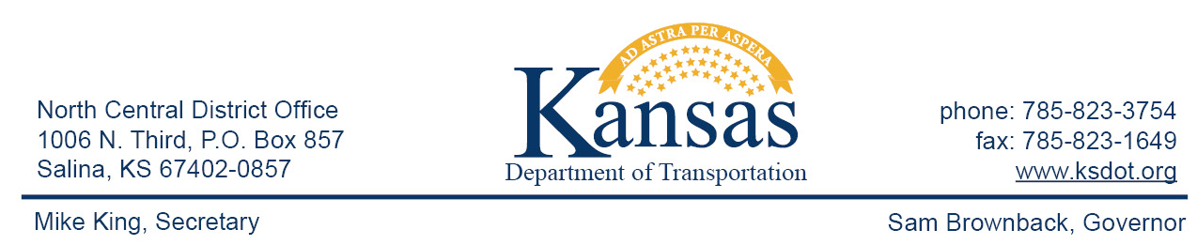

FOR IMMEDIATE RELEASE

July 13, 2015

News Contact: David Greiser (785) 823-3754

I-70 Bridge Deck Repairs in Ellsworth County

Emergency repairs will be made on the east and west bound bridges at the I-70/K-156 Interchange in Ellsworth County. The bridge decks experienced concrete failure requiring immediate attention. Beginning Thursday, July 30, 2015, work begins to remove all fatigued concrete and replace it with new full depth concrete. During construction traffic will be reduced to one lane with a lane width restriction of 12’ and a lowered speed limit of 50 mph. Bridge work will alternate between the eastbound and westbound bridges until all phases of construction are completed.
Drivers need to be prepared to slow and follow the signs thru construction. Plans call for the repairs to be completed in early November, 2015 weather permitting.

###

This information can be made available in alternative accessible formats upon request.
For information about obtaining an alternative format, contact the Bureau of Transportation Information,
700 SW Harrison St., 2nd Fl West, Topeka, KS 66603-3754 or phone 785-296-3585 (Voice)/Hearing Impaired – 711.

Click below to connect to Social Networks:

