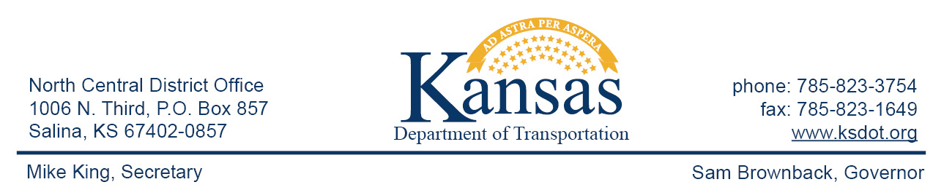

FOR IMMEDIATE RELEASE

June 9, 2015

News contact: David Greiser, (785) 823-3754;
dgreiser@ksdot.org

Bridge Replacement on K-260 in McPherson County

Work began Wednesday, June. 3, 2015, on a K-260 bridge replacement project near Moundridge in McPherson County. The project involves the removal of the bridge on the east-west leg of K-260 then constructing a new bridge in its place. K-260 traffic is being controlled with traffic signals and is reduced to one lane with a width restriction of 10 ft.
Plans call for construction to be completed by mid-November of this year.
Dondlinger & Sons Construction, of Wichita, KS, is the prime contractor for this project. Project costs are $916,449.40.

This project is funded through T-WORKS. For more information concerning the T-works program and specific projects visit the T-works web site at www.ksdot.org/tworks.

####

This information can be made available in alternative accessible formats upon request.
For information about obtaining an alternative format, contact the Bureau of Transportation Information,
700 SW Harrison St., 2nd Fl West, Topeka, KS 66603-3754 or phone 785-296-3585 (Voice)/Hearing Impaired – 711.

Click below to connect to Social Networks:

