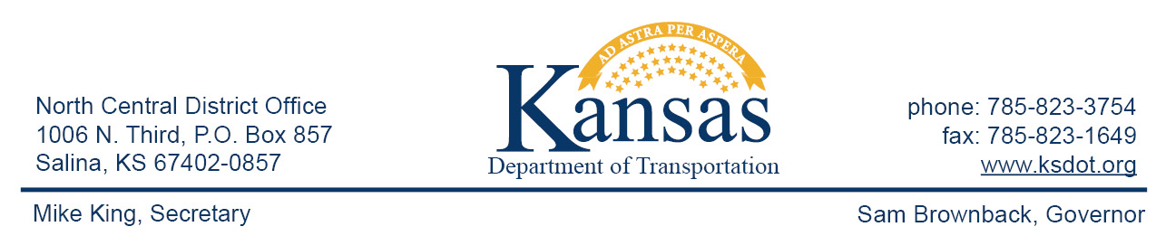

FOR IMMEDIATE RELEASE

June 9, 2015

News Contact: David Greiser (785) 823-3754

US-56/ US-77 Roundabout Work begins in Marion Co.

Work on the new Roundabout to be constructed at the US-56/US-77 intersection in Marion County begins June 11, 2015.
A short detour will be in effect to accommodate construction. Those wanting to go west on US-56 from the US-56/US-77 intersection will go south on US-77 to K-256 then west to join US-56 those coming from the west will use the same detour in reverse.
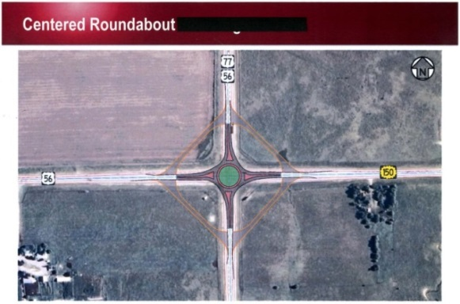
The unique roundabout addresses the need to impact traffic flow by slowing traffic while providing access to oversized loads passing through the state. In this case the Roundabout will have a diamond shaped group of restricted lanes that, when made available, will allow for the oversized loads to drive around the Round-About.
Cornejo & Sons Construction of Wichita, KS.is the prime contractor on this project. Project cost is $5,416,348.27.
Plans call for the project to be completed by mid-December, 2015.

###

This information can be made available in alternative accessible formats upon request.
For information about obtaining an alternative format, contact the Bureau of Transportation Information,
700 SW Harrison St., 2nd Fl West, Topeka, KS 66603-3754 or phone 785-296-3585 (Voice)/Hearing Impaired – 711.

Click below to connect to Social Networks:

