Please read for accuracy and comment.

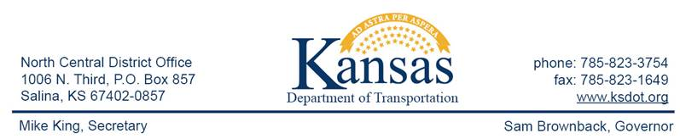

**FOR IMMEDIATE RELEASE**

October 9, 2015

**News contact**: David Greiser, (785) 823-3754

[dgreiser@ksdot.org](mailto:dgreiser@ksdot.org)

**US-56 Improvements in McPherson County (Update)**

As of this morning construction on US-56 east of McPherson will see revised traffic control. Today the I-135 northbound off ramp onto US-56, closed since mid-May, has been reopened to traffic. While US-56 traffic will remain reduced to one lane in each direction from the US-56/Centennial Ave junction east through the Interchange to the US-56/17th Ave junction, beginning today traffic will be switched to the two outside lanes.

The purpose of the project is to extend the 4-Lane pavement east through 17th Ave, including shoulders and replacement of grass median with concrete pavement and add left and right turn lanes at a relocated access break and at 17th Ave.

This is a multi-phased project that will include placing traffic signals at the top of the northbound ramp on I-135. The project should be completed on or about Nov. 1, 2015 weather permitting. Additional news update will follow as warranted.

APAC-KANSAS Inc. Shears Division of Hutchinson, KS is the prime contractor.

####

This information can be made available in alternative accessible formats upon request.

For information about obtaining an alternative format, contact the Bureau of Transportation Information,

700 SW Harrison St., 2nd Fl West, Topeka, KS 66603-3754 or phone 785-296-3585 (Voice)/Hearing Impaired – 711.

 Click below to connect to Social Networks:

[cid:image002.png@01D1028F.70489980](http://www.facebook.com/#!/pages/Kansas-Department-of-Transportation/176590659055811)          [cid:image003.png@01D1028F.70489980](http://twitter.com/#!/kdothq)       [cid:image004.jpg@01D1028F.70489980](http://www.youtube.com/user/kansastransportation)        [cid:image005.jpg@01D1028F.70489980](http://www.flickr.com/photos/kansastransportation)