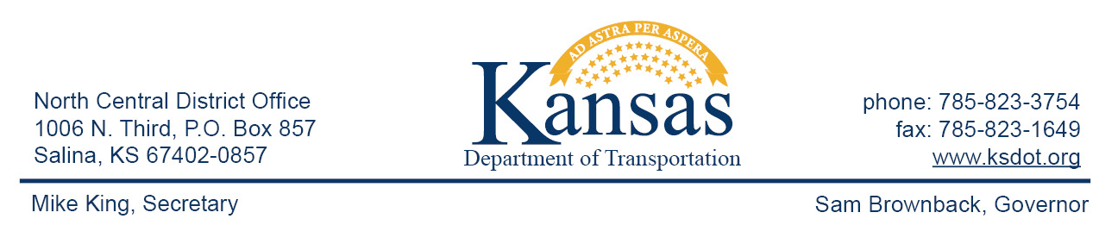

FOR IMMEDIATE RELEASE

March 23, 2016

News Contact: David Greiser (785) 823-3754

I-70 Joint Seal & Patch Repairs in Dickinson County

The Kansas Department of Transportation began highway joint seal and patch repairs on I-70 Monday, March 21st in Dickinson County. The project begins ½ mile west of Abilene then east to a point approximately 2 miles west of the Chapman Interchange (286). Within the construction zone repairs, both eastbound and westbound, will vary both in type and distance. Most traffic control (joint routing and sealing) will be daytime only, however during concrete patch repair traffic control will be in place thru the night. Drivers are expected to be prepared to slow and follow traffic control when I place. Plans call for the repairs to be completed on or about May 2, 2016 weather permitting.

Thru traffic will be reduced to one lane for the duration of the project.

###

This information can be made available in alternative accessible formats upon request.
For information about obtaining an alternative format, contact the Bureau of Transportation Information,
700 SW Harrison St., 2nd Fl West, Topeka, KS 66603-3754 or phone 785-296-3585 (Voice)/Hearing Impaired – 711.

Click below to connect to Social Networks:

