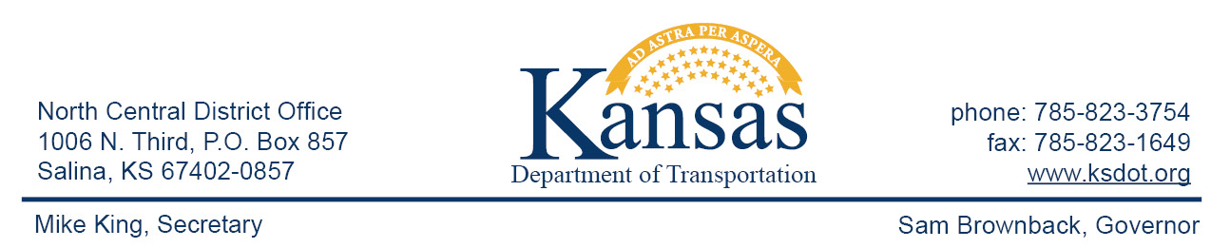

FOR IMMEDIATE RELEASE

April 22, 2016

News contact: David Greiser, (785) 823-3754;
dgreiser@ksdot.org

Box Culvert Replacement on K-149 in Morris County

Beginning Monday, May 2, 2016, a box culvert replacement project will begin on K-149 in Morris County. The culvert is located south of the K-149/K-4 junction and .6 miles north of the K-149/US-56 junction south of White City.
That section of K-149 will be closed to traffic for the duration of the project. Traffic will follow an official detour. Northbound traffic will travel west on US-56 to US-77 then north to K-4 then east to rejoin K-149. Southbound traffic will follow the same detour in reverse.
Plans call for the project to be completed on or about Dec. 3, 2016 weather permitting.
Reese Construction Co. Inc. of Scandia, KS is the prime contractor for this project.

####

This information can be made available in alternative accessible formats upon request.
For information about obtaining an alternative format, contact the Bureau of Transportation Information,
700 SW Harrison St., 2nd Fl West, Topeka, KS 66603-3754 or phone 785-296-3585 (Voice)/Hearing Impaired – 711.

Click below to connect to Social Networks:

