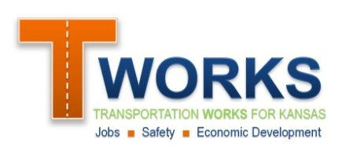
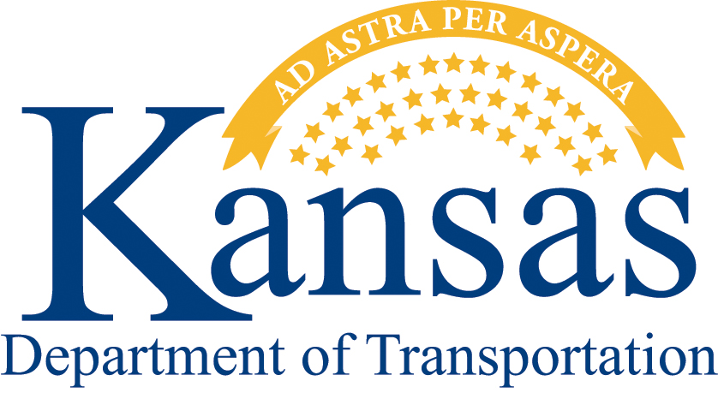
Supporting the Economy
General Inquiry Application

KDOT has several programs designed to partner with local governments to support the state’s economy, many of which compliment each other. To align the proposed project with the best program(s), please submit this general inquiry application first. After a brief review, KDOT will provide a detailed program-specific application that will allow for a comprehensive description of the proposed project. If you have any questions, please contact Mike Moriarty at 785.296.8864 or ecodevo@ksdot.org .

- General Applicant Information
- Name of governmental unit: Click here to enter text.
- Name and title of primary contact person: Click here to enter text.
Should be an elected official or employee of the governmental unit
Address: Click here to enter text.
Phone Number: Click here to enter text.
Email: Click here to enter text.
- Project Location and DescriptionChoose an item.
- Type of Project (check all that apply): Road/Highway Rail Airport Transit
- Project Location: Click here to enter text.
- Project scope (description of work): Click here to enter text.
- Estimated Cost of the Project
- Total Estimated Cost in 2011 Dollars: Click to enter total costs
- Local Match Available: Click to enter local match

- Briefly describe the nature of the proposed local match
Click here to enter text.

- Benefits of the project
- Briefly describe the nature of the transportation problem at this location and the transportation benefits that would result from the project:
Click here to enter text.

- Are there any economic benefits of the project? If so, please briefly describe.
Click here to enter text.
- History of the project
  - Briefly describe how this project came about
Click here to enter text.
- Timing of the project
- Briefly describe the desired timing of the project. If the timing is critical, please describe why:
Click here to enter text.

Submit the Application:
- By email it to Mike Moriarty ecodevo@ksdot.org
- By mail to:
Kansas Department of Transportation
Attn: Alicia Johnson-Turner
Eisenhower State Office Building
700 Harrison, 2nd Floor
Topeka KS 66603
What’s Next?
KDOT will review your application for eligibility within its local partnership programs and provide you with the supplemental application that best fits your project. If you have any questions, please contact Mike Moriarty at 785.296.8864 or ecodevo@ksdot.org .

