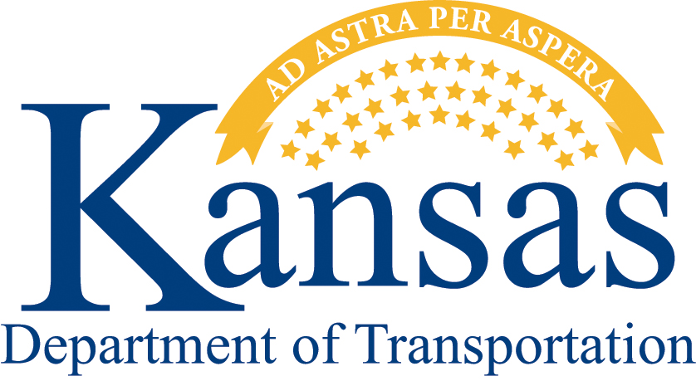
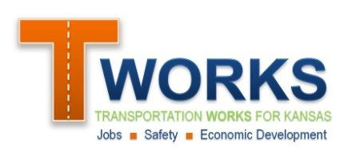
Local Partnership Opportunities
GENERAL APPLICATION

KDOT has several programs designed to partner with local governments to improve the State’s transportation system and support the State’s economy, many of which complement each other. If you are new to these programs or if you are unsure which program best fits your project, KDOT strongly encourages you to start with this General Local Partnership Opportunity Application. After a brief review, KDOT will provide a detailed program-specific application that will allow for a comprehensive description of the proposed project. If you have any questions, please contact Wade Wiebe at 785.296.3585 or wwiebe@ksdot.org.

- General Applicant Information
- Name of governmental unit: Click here to enter text.
- Name and title of primary contact person: Click here to enter text.
Should be an elected official or employee of the governmental unit
Address: Click here to enter text.
Phone Number: Click here to enter text.
Email: Click here to enter text.
- Which mode(s) of transportation does your project contain? (check all that apply)
State Highway Local Road Railroad Aviation Transit
- Project Location and Description
- Project Location: Click here to enter text.
- Project scope (description of work): Click here to enter text.
- Estimated Cost of the Project
- Total Estimated Cost in 2011 Dollars: Click to enter total costs
- Local Match Available: Click to enter local match

- Briefly describe the nature of the proposed local match:
Click here to enter text.
- Benefits of the project
- Briefly describe the nature of the transportation problem at this location and the transportation-related benefits that would result from the project:
Click here to enter text.
- Are there any economic benefits of the project? If so, please briefly describe.
Click here to enter text.

- History of the project
Briefly describe how this project came about:
Click here to enter text.
- Timing of the project
Briefly describe the desired timing of the project. If the timing is critical, please describe why:
Click here to enter text.

Submit the Application:
- By email to Wade Wiebe at wwiebe@ksdot.org
- By mail to:
Kansas Department of Transportation
Attn: Wade Wiebe
Director of Partner Relations
Secretary of Transportation’s Office
Eisenhower State Office Building
700 Harrison, 2nd Floor West
Topeka KS 66603
What’s Next?
KDOT will review your application for eligibility for KDOT’s local partnership programs and provide you with the supplemental application that best fits your project. If you have any questions, please contact Wade Wiebe at 785.296.3585 or wwiebe@ksdot.org

