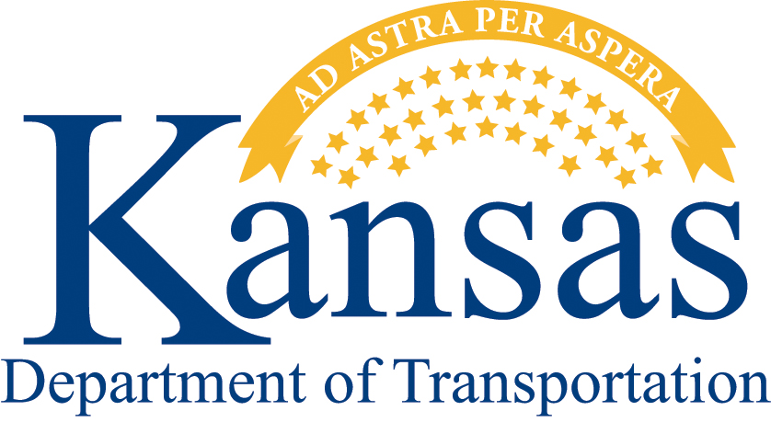
Kansas Airport
Improvement Program
Application Form

If your project has direct ties to the economy by creating or sustaining jobs or if you are new to the Air Program, KDOT strongly encourages you to start with the General Local Partnership Opportunity Application available at www.ksdot.org/tworks/ecodevo/downloads/genapp2011. KDOT is also here to help throughout the application process, so if you have any questions, please don’t hesitate to contact George Laliberte at 785.296.2553 or KDOTAviation@ksdot.org.
- General Applicant Information
- Name of applicant/sponsor: Click here to enter text.
- Name and title of primary contact person: Click here to enter text.
Address: Click here to enter text.
Phone Number: Click here to enter text.
Email: Click here to enter text.
- 3-Letter Airport Identifier: Click here to enter text.
- Project Category: Design/Planning Modernization Equipment Preservation
- Project Description – Click here to enter text.

- Estimated Cost of the Project – Please be specific about the nature of the cost, report in current
dollars
- Total Estimated Cost in current Dollars: Click to enter total costs.
- Local Match Available: Click to enter local match
KDOT will participate in the cost of construction and construction engineering at a rate not
to exceed:
- 90% for sponsors with a population of less than 3,000 and for privately-owned and public-use airports
- 75% for sponsors with a population between 3,000 and 10,000
- 50% for sponsors with a population greater than 10,000
- 95% for Planning and Design projects
Maximum support is not to exceed:
- $800,000 of state funds for most project
- $1.2 million for full-depth reconstruction of existing primary runway
- $1.6 million for new primary runways
- Project Timing – Indicate the Fiscal Year (FY) the application is to be considered
FY 2012 (July 1, 2011 - June 30, 2012)
FY 2013 (July 1, 2012 – June 30, 2013)

Additional Information
Attach any information or documentation to the application that you wish to be considered in evaluating the request. Such items might include photographs, engineering plans, economic impact statements, in-kind work, local support, situations unique to the project, and benefits derived. These items may be in a narrative form with focus on specifics and avoiding generalities.

It is expected that projects will vary greatly in cost and complexity. Sponsors are encouraged to review the proposed project with the Division of Aviation. Smaller projects may not require engineering or pre-planning that would be required for major runway rehabilitation projects. Sponsors will be responsible for all preliminary engineering and construction activities including plan preparation and letting of a contract. A contractual agreement will be executed between the Sponsor and the Kansas Department of Transportation that encompasses the work to be accomplished.

For complete program guidelines please visit http://www.ksdot.org/divaviation/pdf/ProgramOutline.pdf.

Submit Application by email to KDOTAviation@ksdot.org and ecodevo@ksdot.org.
Or, submit Application by mail to:
Kansas Department of Transportation
Division of Aviation
Eisenhower State Office Building
700 Harrison, 2nd Floor
Topeka KS 66603
Phone: 785.296.2553

