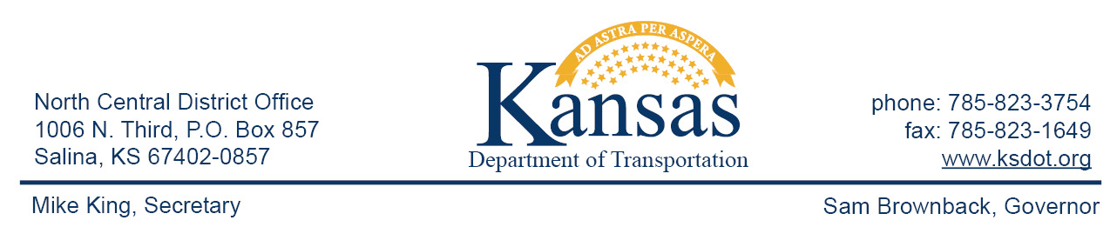

FOR IMMEDIATE RELEASE

Aug. 31, 2015

News contact: David Greiser, (785) 823-3754;
dgreiser@ksdot.org

RR Crossing project on K-148 in Washington County

The Union Pacific Railroad plans to close the tracks on K-148 north of Hanover for repairs from 8 am, Sept 1, 2015, through 4 pm, Sept. 3, 2015. While repairs are being made traffic will follow a detour around the area. The detour will take northbound K-148 traffic south to US-36 then east to US-77 then north to N-8 then west to N-112 Which becomes K-148 at the KS/NE line. Southbound traffic will follow the route in reverse.

####

This information can be made available in alternative accessible formats upon request.
For information about obtaining an alternative format, contact the Bureau of Transportation Information,
700 SW Harrison St., 2nd Fl West, Topeka, KS 66603-3754 or phone 785-296-3585 (Voice)/Hearing Impaired – 711.

Click below to connect to Social Networks:

