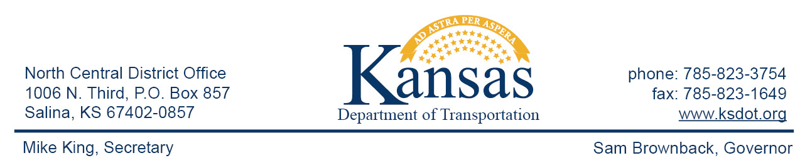

FOR IMMEDIATE RELEASE

June 1, 2015

News contact: David Greiser, (785) 823-3754;
dgreiser@ksdot.org

K-148 Mill & Overlay in Jewell/Republic Counties
(corrected)

Work began June 1, 2015 on a Mill & Overlay on K-148 in Jewell & Republic Counties. The project begins at the K-148/K-28 junction in Jewell County then east to the K-148/US-81 junction in Republic County.

Traffic will be carried thru construction via Flaggers and a Pilot Car during daylight hours only with a lane width restriction of 10’.

Plans call for the project to be completed on or about September 18th weather permitting.

####

This information can be made available in alternative accessible formats upon request.
For information about obtaining an alternative format, contact the Bureau of Transportation Information,
700 SW Harrison St., 2nd Fl West, Topeka, KS 66603-3754 or phone 785-296-3585 (Voice)/Hearing Impaired – 711.

Click below to connect to Social Networks:

