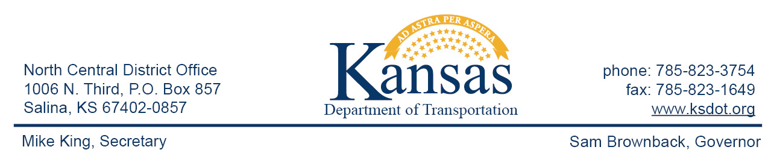

FOR IMMEDIATE RELEASE

July 22, 2015

News contact: David Greiser, (785) 823-3754;
dgreiser@ksdot.org

Surface Recycle & Chip Seal for K-80 in Clay County (UPDATE)

KDOT will apply a Surface Recycle followed by a Chip Seal on K-80 in Clay County beginning Monday, July 27, 2015. The project begins at the east Morganville city limit then east to the K-80/K-15 junction. Traffic control will be provided by flaggers and a pilot car with a 12’ lane width restriction during daylight hours. Plans call for the project to be completed on or about August 21st weather permitting.
The purpose of this project is to extend the life of the highway and improve ride quality.

This project is funded through T-WORKS. For more information concerning the T-works program and specific projects visit the T-works web site at www.ksdot.org/tworks.

####

This information can be made available in alternative accessible formats upon request.
For information about obtaining an alternative format, contact the Bureau of Transportation Information,
700 SW Harrison St., 2nd Fl West, Topeka, KS 66603-3754 or phone 785-296-3585 (Voice)/Hearing Impaired – 711.

Click below to connect to Social Networks:

