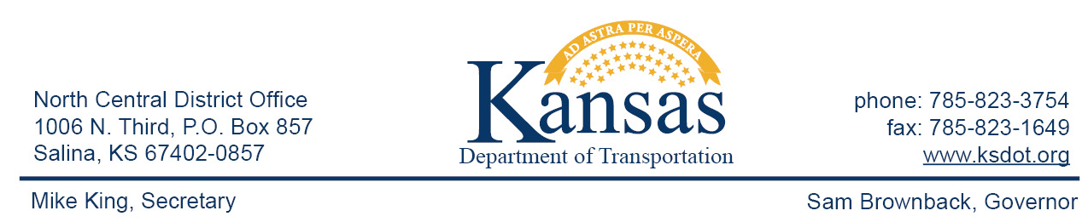

FOR IMMEDIATE RELEASE

February 29, 2016

News contact: David Greiser, (785) 823-3754;
dgreiser@ksdot.org

K-148 Culvert Replacement in Republic County

Work begins Tuesday, March 1, 2016, on a culvert replacement on K-148 in Republic County. The project is located 5.7 miles east of US-81 on K-148 crossing over the Coal drainage creek in Republic County.

Westbound traffic will be detoured beginning at the K-148/K-15 junction north on K-15 then west on US-36 to US-81 then south to rejoin K-148. Eastbound traffic will follow the same detour in reverse.

Plans call for the project to be completed on or about July 15, 2016 weather permitting.

Reece Construction Co. Inc. of Scandia, KS is the prime contractor for this project. Project cost is $368,288.40.

####

This information can be made available in alternative accessible formats upon request.
For information about obtaining an alternative format, contact the Bureau of Transportation Information,
700 SW Harrison St., 2nd Fl West, Topeka, KS 66603-3754 or phone 785-296-3585 (Voice)/Hearing Impaired – 711.

Click below to connect to Social Networks:

