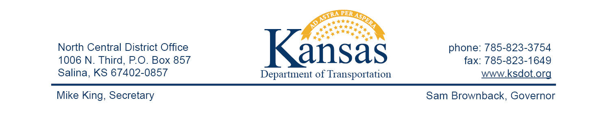

**FOR IMMEDIATE RELEASE**

April 22, 2016

**News contact**: David Greiser, (785) 823-3754

[dgreiser@ksdot.org](mailto:dgreiser@ksdot.org)

**Surface Recycle and Chip Seal on K-4 in Dickinson County**

A project on K-4 in Dickinson County begins Monday, April 25, 2016, starting at the city of Hope then east to the K-4/K-177 junction. Work will include heating and removing the top 2 inches of asphalt and mixing that material with rejuvenating oils and emollients then laying that material back down on the highway. That process will be followed by a chip sealing surface layer. Plans call for the project to be completed on or about July 30, 2016 weather permitting.

Traffic control will be by pilot car and flagmen during daylight hours only. Drivers approaching the work zone need to slow and be prepared to stop.

The purpose of this project is to extend the life of and improve the ride quality the highway.

Dustrol Inc. of Towanda, KS, is the prime contractor. Project cost is $3,216,759.17.

####

This information can be made available in alternative accessible formats upon request.

For information about obtaining an alternative format, contact the Bureau of Transportation Information,

700 SW Harrison St., 2nd Fl West, Topeka, KS 66603-3754 or phone 785-296-3585 (Voice)/Hearing Impaired – 711.

 Click below to connect to Social Networks:

[](http://www.facebook.com/#!/pages/Kansas-Department-of-Transportation/176590659055811)          [](http://twitter.com/#!/kdothq)       [cid:image004.jpg@01CE4FF0.697CB950](http://www.youtube.com/user/kansastransportation)        [cid:image005.jpg@01CE4FF0.697CB950](http://www.flickr.com/photos/kansastransportation)