December 2020 Version 2.0
State of Kansas
Field Operations Guide
(KS-FOG)
Interoperable Communications

Letter of Introduction
The Kansas Field Operations Guide (KS-FOG) is a collection of technical reference material to aid Communications Unit personnel in establishing solutions to support communications during emergency incidents and planned events. The KS-FOG includes information from the Kansas Tactical Interoperable Communications Plan (TICP) and data from other State communications documents; formatted as a pocket-sized guide.
The KS-FOG contains local, territory, and national interoperability channels. These channels should be programmed into all public safety radios in the appropriate frequency band. If geographic restrictions on some channels preclude their use within the State, they may offer an interoperability option when responding out of state where the restrictions may not apply.
Please send updates, corrections, or comments about the KS-FOG or requests for additional copies to the Statewide Interoperability Coordinator (SWIC).
Thank you,
Kansas Communications Credentialing Committee
“The ability of Public Safety responders to share information via voice and data communications systems on demand, in real time, when needed and as authorized.”
SAFECOM
Record of Change
Version # | Date | Pages Changed | Change Date | Change Made By
1.0 | 12/2015
2.0 | 12/2020 | 1, 2, 9, Appendix A, Appendix D | 12/2020 | J. Bryant, SWIC

About this Guide
Points of Contact for this Guide
Agency: | Kansas Division of Emergency Management  Emergency Communications Section
Title: | Statewide Interoperability Coordinator
Address: | 2722 SW Topeka Blvd., Topeka, KS 66611
24/7 Phone: | 785-452-0974
The purpose of the Kansas Field Operations Guide (KS-FOG) is to be used to increase efficiency in establishing interoperable communications during incidents, create a consistent knowledge base of interoperable communications channels and networks, and provide a helpful tool for pre-planning and interoperable communications training and exercises.
Please send updates, corrections, or comments about the KS-FOG to the Kansas Emergency Communications Section.

This page intentionally left blank

TABLE OF CONTENTS

1 Interoperable Communications 1
1.1 Kansas Statewide Interoperable Communications System (KSICS) 1
1.2 MOTOBRIDGE 5
1.3 Common Issues 14
1.4 Agency Responsibilities and Rights 15
1.5 Prioritization and Shared Use of Regional Interoperability Assets 16
1.6 Incident Command System (ICS) 20
1.7 Position Descriptions 22
1.8 ICS Personnel Common Responsibilities 24
1.9 Communications Unit Leader (COML) Position Checklist 26
1.10 Request for MOTOBRIDGE Channel Assignment 30
2 Interoperability Assets 33
2.1 General Rules of Use 33
2.2 National and State Interoperability Channels (MOTOBRIDGE) 36
2.2.1 VHF Low Band (State) 37
2.2.2 VHF High Band (National) 37
2.2.3 UHF Band (National) 38
2.2.4 800 MHz Band (National) 39
2.3 Mutual Aid Channels (Non-Federal) 40
2.3.1 VHF Low Band Non-Federal National Interoperability Channels 41
2.3.2 VHF High Band Non-Federal National Interoperability Channels 42
2.3.3 VHF Non-Federal Inland Interoperability Channels 43
2.3.4 UHF Non-Federal National Interoperability Channels 44
APPENDIX A Regional Interoperability Information A-1
APPENDIX B Plain Language Words and Phrases B-1
APPENDIX C Phonetic Alphabet Standards C-1
APPENDIX D FirstNet Incident Communications Support D-1
APPENDIX E Reference Materials E-1
APPENDIX F Incident Command System (ICS) Communication Forms F-1
APPENDIX G Glossary and Terms G-1
APPENDIX H Web Site Links H-1

Interoperable Communications
Interoperable communications are required whenever multiple jurisdictions and/or multiple disciplines respond to an incident. Interoperable communications can be achieved in a number of different ways. The following procedures will be utilized to achieve interoperable communications.

Kansas Statewide Interoperable Communications System (KSICS)
KSICS is utilized for interoperability with users on the statewide 800 MHz P25 digital trunked radio system. KSICS is not intended to be made interoperable with local level radio systems through the use of mobile gateway or console patches. Patching of local channels to talkgroups on KSICS is prohibited.
The KSICS and the statewide interoperable template give communications capabilities to command and operational personnel responsible for responding to a regional incident requiring multiple jurisdictions and disciplines. It is intended to support multi-agency, multi-jurisdictional communication capabilities, when other means of communication are not adequate. KSICS serves as a communication system available to public safety users, state agencies and local agencies who have elected to migrate to it.
- The following protocols will be utilized when KSICS is activated for interoperability purposes:
  - NIMS compliant ICS structure will be utilized on the response.
  - Plain language will be utilized for radio communications in accordance with NIMS standards.
  - Unit identification will consist of home city or county and agency, to avoid any confusion of units that might share the same identifier.
  - All radios will operate in a “clear” mode, if encryption capable, unless otherwise directed.
  - The Incident Commander, or COML if assigned, will ensure that utilized talkgroups are monitored while in use.
- The following list is a hierarchy of projected operational needs based on priority, with the first operation holding the highest priority. The list is provided for operational context for use of the KSICS system for interoperability.
  - A large-scale emergency incident requiring multi-agency, multi-jurisdictional response.
  - Everyday response-level communications to emergency or urgent incidents that require mutual aid response from multiple agencies, when other common means of communication are not available.
  - Special event control activities, generally of a pre-planned nature, involving joint participation of two or more agencies.
  - Drill, maintenance, and test exercises.
- Procedures for use of KSICS for interoperable communications:
  - Select the talkgroups that will be utilized for the response.
    - Local incidents should utilize regional, interoperability talkgroups (i.e., PSAP, MED, TAC 1, TAC 2, AES, etc.) for small scale events. Regional talkgroups are listed in Appendix A.
    - Large multi-agency incidents or training should utilize ICS talkgroups (i.e., Zone 1 (ICS-1 through ICS-10, COMMON-1 through COMMON-4, and COMU) and Zone 2 (ICS-11 through ICS-20, COMMON-5 through COMMON-8, and COMU) for larger scale events of longer duration (i.e., more than one day.) ICS talkgroups are listed in Appendix A.
    - Users accessing Kansas Highway Patrol (EVNT) talkgroups should refer to their Shared-Use Agreement signed with the Kansas Department of Transportation.
  - Notify responding units of the appropriate talkgroups and have the units switch to the designated interoperability resource. Confirm that responding units are operating on the appropriate talkgroup.
    - Monitor the talkgroups to address requests as required.
    - Monitor the talkgroups for problems that may arise that may require technician intervention, or for system problems.
- When the interoperability resources of KSICS are no longer required, the following deactivation procedures should be followed:
  - An announcement that the KSICS interoperability resources are being operationally deactivated will be made over the talkgroup(s) being utilized.
  - Prior to deactivation of the talkgroups, agencies should ensure that all personnel have returned to their appropriate home systems.
  - After deactivation of the interoperability resources, normal operations may be resumed.

MOTOBRIDGE
The MOTOBRIDGE system is a fixed-site interoperability gateway that is located on 76 tower sites owned by the Kansas Department of Transportation (KDOT). MOTOBRIDGE is utilized for interoperability with users on the statewide, P25, digital, trunked KSICS radio system, and local radio system users in the VHF Low-band, VHF High-band, UHF, or 800 MHz spectrum.
As with any other radio system, actual coverage depends on issues such as terrain, frequency band, antenna height, weather, and functionality of the end-user radio equipment. Using both national and state interoperability channels, MOTOBRIDGE can connect or “patch” pre-determined channels between disparate radio systems. This can be accomplished on a single site (Bourbon VHF patched to Bourbon UHF) or across multiple sites (Bourbon VHF patched to Sumner 800 MHz).
- The intent of this procedure is to establish an orderly, workable radio resource for the use of operational, as well as command and control personnel.
- MOTOBRIDGE is intended for multi-disciplinary or multi-jurisdictional use when other common means of radio communications are not available. Generally, the system should be used by responders and critical facilities during activities that directly impact life safety and the preservation of property.
- MOTOBRIDGE channels may be temporarily used by agencies that have unexpectedly lost local communications infrastructure due to external forces. If the system is being used for this purpose, KDOT and KHP should be notified in order to avoid disruptions (such as maintenance) of service.
- The following protocols will be utilized when KSICS interoperability procedure is in effect:
  - NIMS compliant ICS structure will be utilized on the response.
  - Plain language will be utilized for radio communications in accordance with NIMS standards.
  - Unit identification will consist of home city or county and agency, to avoid any confusion of units that might share the same identifier.
  - All radios will operate in a “clear” mode, if encryption enabled, unless otherwise directed.
  - The Incident Commander, or COML if assigned, will ensure that utilized talkgroups are monitored while in use.
- The following list is a hierarchy of projected operational needs based on priority, with the first operation holding the highest priority. The list is provided for operational context for use of the KSICS system for interoperability.
  - A large-scale emergency incident requiring multi-agency, multi-jurisdictional response.
  - Everyday response-level communications to emergency or urgent incidents that require mutual aid response from multiple agencies, when other common means of communication are not available.
  - Special event control activities, generally of a pre-planned nature, involving joint participation of two or more agencies.
  - Drill, maintenance, and test exercises.
- Procedures for use of the MOTOBRIDGE system.
  - MOTOBRIDGE patch can be requested in a variety of ways including:
    - Radio by using a call-in channel
    - Telephone by calling KHP Dispatch at 785-827-4437 or *47 from a cell phone
    - Teletype to KHP from a Public Safety Answering Point (PSAP)
  - Use the following procedure to initiate a MOTOBRIDGE patch via radio:
    - Contact “KHP Dispatch” on the designated call-in channel and identify by using home city/county + radio number (Logan County 601) or agency/facility name (Logan County Hospital). The requestor should also indicate their current location by county.
    - Once KHP answers request a MOTOBRIDGE patch then provide the bands and location(s) of the patch.
    - Remain on the call-in channel. As a courtesy, KHP will notify the requestor that the patch is ready and the appropriate tactical channels to be used. Once complete, users will switch to the tactical channels to communicate.
    - Example:
“Logan County 601 to KHP Dispatch from Wallace County”
“KHP Dispatch… go ahead”
“Request MOTOBRIDGE patch”
“Go ahead with request”
“Patch Wallace UHF to Wallace VHF”
“Wallace VTAC12 and Wallace UTAC42 are patched and ready”
  - Use the following procedure to initiate a MOTOBRIDGE patch via telephone:
    - Contact KHP Dispatch via telephone, utilizing either the 10 digit number (785-827-4437) or *47 from a cell phone.
    - Identify yourself by using home city/county and your agency or radio number.
    - Request a MOTOBRIDGE patch, providing bands and locations needed in the patch.
    - Remain on the telephone with KHP Dispatch until notification that the patch is ready and the appropriate tactical channels to be used is received. Once complete, users will switch to the tactical channels indicated to communicate.
  - Use the following procedure to initiate a MOTOBRIDGE patch via teletype to KHP from a PSAP.
    - Send a teletype to KHP (utilize the phonetic letter for your troop area) containing the following information:
      - Nature of the activity requiring the patch. This sets the priority of the request for KHP dispatch.
      - Location(s) and band(s) needed to be patched.
      - A request that notification, with specific channels patched, be made.
    - Example:
HAVE OFFICERS WORKING A MANHUNT IN OUR COUNTY, REQUESTING A MOTOBRIDGE PATCH.
PATCH REQUEST AS FOLLOWS:
- RENO CO UHF
- RENO CO VHF
- RENO COUNTY 800 DIGITAL EVENT
PLEASE ADVISE, WITH SPECIFIC CHANNELS PATCHED, WHEN COMPLETE.
THANKS IN ADVANCE.
  - Patch Coordination
    - In many cases, end users of a MOTOBRIDGE patch will be aware that the patch is being connected. This is accomplished by on-scene coordination through word of mouth or by other electronic means such as telephone or teletype. Every effort to coordinate a patch in the field should be taken.
    - In some cases, a patch may be requested without the targeted user’s knowledge. Generally, this applies when a requestor does not have the means to notify or coordinate with the target user. This is known as a “cold call”. In the event of a cold call, KHP Dispatch will make every effort to notify the target user. To do so, KHP Operators will need guidance from the requestor such as the agency, name or radio number of the target, and their agency contact information, if available. Unless notified of a cold call situation at the time of request, KHP Dispatch will assume that the patch has already been coordinated in the field. It is the responsibility of the requestor to ask for a cold call notification.
  - When the interoperability resources of MOTOBRIDGE are no longer required, the following deactivation procedures should be followed:
    - An announcement that the MOTOBRIDGE interoperability resources are being operationally deactivated will be made over the patch.
    - Prior to deactivation of the patch, agencies should ensure that all personnel have returned to their appropriate home systems.
    - Contact KHP Dispatch via call channel, telephone or teletype and request that the patch be discontinued. Patches will remain active until this request is received by KHP Dispatch.
    - After deactivation of the interoperability resources, normal operations should be resumed.
  - License Requirements
    - All fixed-site MOTOBRIDGE base-stations and repeaters located on the KDOT towers are owned by KDOT and licensed through the FCC. Any other base-station, control-station or repeater at the local level using the National or State Interoperability channels must be licensed by the FCC to the appropriate local government agency.
    - For mobile and portable use, the National Interoperability Channels are covered under a “blanket license”. If an agency is ELIGIBLE for a FCC part 90 radio license, the National Interoperability Channels may be programmed into equipment without having the channels individually licensed to the agency. **The state VHF Low-Band channels (39.58/39.70) used by MOTOBRIDGE require an FCC license through a local agency for fixed-site and mobile / portable use.**
    - Users of KSICS require no local licensing for the use of the system, assuming that the proper documentation has been filed with KDOT. Licenses for these channels are coordinated and held by KDOT on behalf of the local agency.
  - Signaling
    - For the purpose of this document, signaling is defined as any non-voice signal produced by radio equipment to identify, notify, or otherwise dispatch and coordinate responders. Examples of signaling include, but are not limited to:
      - Paging
      - DTMF
      - Voice Encryption
      - Push-to-Talk identification
    - MOTOBRIDGE uses nationally recognized interoperability channels designated for multi-jurisdictional and multi-disciplinary use. Currently there are no national signaling standards for these channels. The lack of standards could potentially lead to confusion and channel congestion. To avoid unnecessary confusion and to reduce channel congestion, signaling functions are not allowed on the MOTOBRIDGE system.

Common Issues
- Incident using radio channels in more than one band (VHF, UHF, and/or 700/800 MHz)
- Incident using different radio bands via console or gateway patches
- Unable to communicate critical information due to radio congestion
- Unfamiliar with radio system(s) or assigned radio functionality
- Instructions and assignments not clear
- Have no or inadequate communication with your crew members or supervisor
- Dispatch to dispatch channel patching
- Inadequate number of tactical channels available or assigned
- Multiple conversations on the same talkgroup or channel
- Ensure that the radio system that you are using for interoperability completely supports the incident with good radio coverage
- High level of background noise (i.e., wind, generators, power tools, fire pumps)
- Emergency button activation – who is receiving the notification, who is authorized to clear
- Multiple agencies performing radio programming at the incident
- Organizations in the system not using the same vocabulary
- Mobile gateway devices being used in a strategic (wide-area) rather than tactical (local) environment
- Multiple mobile gateways available at the incident
- Responding agencies have not identified a single Communications Unit Leader (COML) for the incident
- Working in the deep interior of a building, parking garage, or underground

Agency Responsibilities and Rights
Agencies will retain the following responsibilities and rights:
- Agencies are responsible for complying with MOUs and Agreements developed through the State in coordination with their respective jurisdictions.
- Authorized representatives of agencies participating in this plan have the authority to request the use of equipment, including systems and mobile assets, in accordance with Standard Operating Procedures (SOPs).
- Where applicable, agencies will be responsible for consistently maintaining, testing, and exercising connectivity to interoperable communications.
Incident Commanders retain the right to decide how to utilize interoperable communications.

Prioritization and Shared Use of Regional Interoperability Assets
The Incident Commander, or designee, in conjunction/cooperation with their counterparts in other involved agencies, will have the authority to request the use of interoperable assets. Once Incident Command has been established, Command Staff or the Communications Unit Leader (when designated) direct the further coordination and delegation of the interoperable communications assets assigned to the event or incident in question.
When the same resources are requested for two or more incidents, resource assignments should be based on the priority levels in accordance with the National Incident Management System (NIMS).
In the event of multiple simultaneous incidents within the same priority, the resources should be allocated according to NIMS.
In response to events or incidents which cross over jurisdictional boundaries, there potentially could be competing demands and priorities for interoperable communications assets.
Agencies should activate needed interoperable assets to respond effectively and to minimize any negative impact on surrounding agencies or jurisdictions. Specifically, interoperable communications should be established with the following techniques, listed in increasing order of complexity:
- Utilize face-to-face communications wherever appropriate. For example, the co-location of all Command and General Staff at the Incident Command Post (ICP) provides the best direct communications and reduces the demand on interoperability resources
- Employ local communications assets until such time as either those assets become taxed or inadequate based on the nature and/or scope of the incident
- If response agencies are users of a shared system, utilize that shared system to establish interoperable communications
- If response agencies operate on disparate systems, utilize shared or mutual aid channels to establish interoperable communications.
- If response agencies do not share systems or channels, utilize a gateway solution to establish interoperable communications
- Where interoperable communications cannot otherwise be established between response agencies, utilize swap or cache radios to establish operable communications for responders
- If no other method of interoperability can be established, relay communications through staff members
When the same resources are requested for two or more incidents, resource assignments should be based on the priority levels listed below:
- Disasters, large scale incidents, or extreme emergencies requiring mutual aid or interagency communications
- Incidents where imminent danger exists to life or property
- Incidents requiring the response of multiple agencies
- Pre-planned events requiring mutual aid or interagency communications
- Incidents involving a single agency where supplemental communications are needed for agency use
- Drills, tests and exercises
In the event of multiple simultaneous incidents within the same priority level, the Incident Commander or Unified Command (if formed) shall have allocation authority and shall allocate resources with the following priorities in mind:
- Incidents with the greatest level of exigency (e.g., greater threat to life or property, more immediate need, etc.) have priority over less exigent incidents
- Agencies with single/limited interoperable options have priority use of those options over agencies with multiple interoperable options
When at all possible, agencies already using an interoperable asset during an event should not be redirected to another resource.

Incident Command System (ICS)
ICS is a key feature of NIMS. It is a widely applicable management system designed to enable effective, efficient incident management by integrating a combination of facilities, equipment, personnel, procedures and communications operating with a common organizational structure. ICS is used to organize on-scene operations for a broad spectrum of incidents/events and guides the process for planning, building and adapting that structure. ICS is based on the command principles of unity of command, chain of command, span of control, delegation of authority and division of labor. The five major functional areas of ICS are command, operations, planning, logistics and finance/administration. The Incident Management – Major Incident flow can be found on the following page.
SAMPLE
Incident Management
- Major Incident

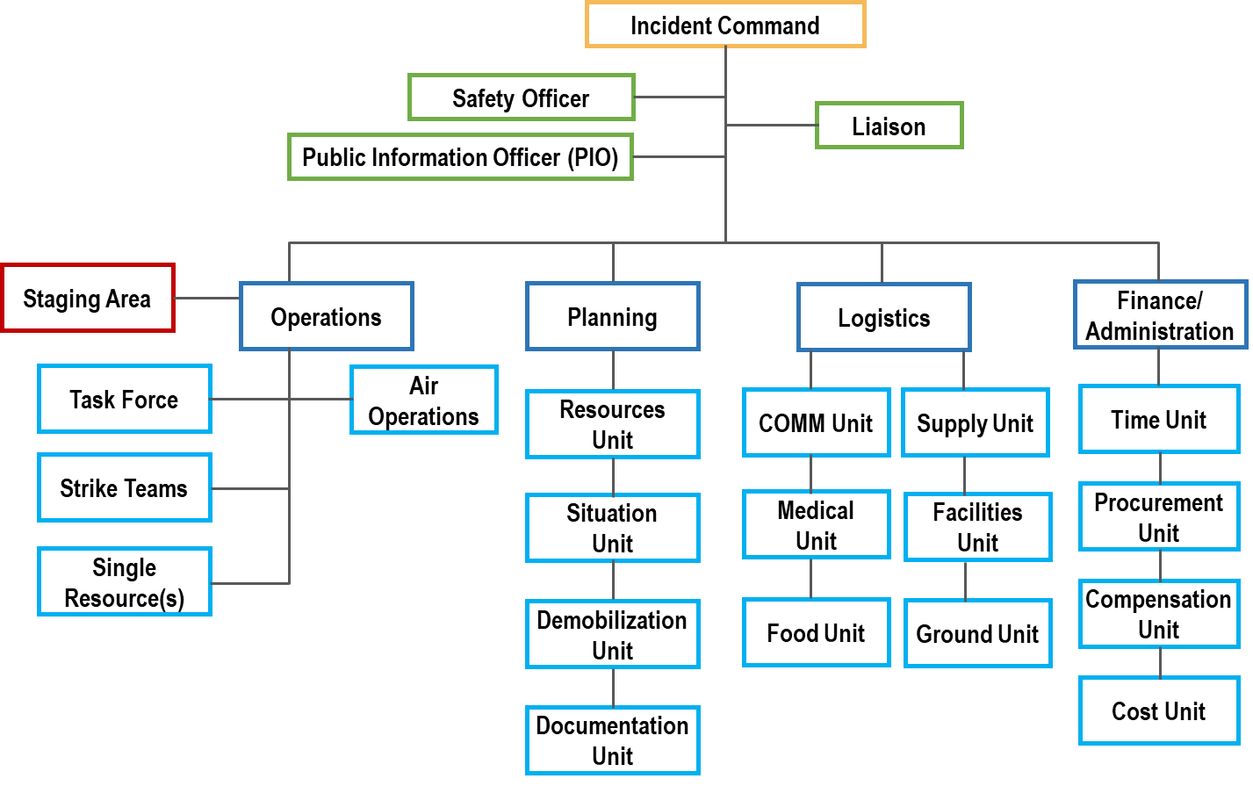

Position Descriptions
At an Incident/Event
The Communications Unit is in the Service Branch of the Logistics Section of the ICS. Listed below are the Communication Unit Organization position titles and responsibilities.
- Communications Unit Leader (COML) –Manages the technical and operational aspects of the Communications Function during an incident or event. Develops National Incident Management System (NIMS)/Incident Command System (ICS) Form 205 Incident Radio Communications Plan and supervises the communication unit.
- Incident Communications Technician (COMT) – Deploys advanced equipment and keeps it operational throughout the incident/event.
- Information Technology Service Unit Leader (ITSL) – Is responsible for the provision and support of computer hardware, system and application software as well as data communications and IT services infrastructure during an incident or event.
- Technical Specialist (THSP) – Allows for the incorporation of personnel who may not be formally certified in any specific NIMS/ICS position. THSPs may include Local Agency Radio Technicians (as opposed to the COMT), Telephone Specialists, Gateway Specialists, Data/IT Specialists, and or Cache Radio Specialists.
- Incident Communications Center Manager (INCM) – Supervises the operational aspects of the Incident Communications Center (ICC) (Mobile Unit and/or Fixed Facility). During an incident, the ICC is designed to absorb incident traffic in order to separate that traffic from the day-to-day activities of the dispatch center. The ICC is typically located at the Incident Command Post (ICP) in a fixed site, tent, trailer, mobile communications unit.
- Incident Tactical Dispatcher (INTD) – Dedicated telecommunications support to all public safety operations during an emergency incident, tactical operation, or planned event. INTDs provide any/all communications for the assigned incident during an activation/deployment and may operate in Public Safety Communications Center (PSCC) or in the field Experienced telecommunicator assigned to support specific field units during an incident, event, or special operation.
- Radio Operator (RADO) - Staffs a radio at the ICC and is responsible for documenting incoming radio and telephone messages. Incident Dispatchers or Tactical Dispatchers are used as RADOs.
Dispatch Center or Emergency Operations Center (EOC)
- Communications Coordinator (COMC) – The COML will work with the COMC to coordinate communications with other dispatch centers and the incident communication plan. Locally, the jurisdictional dispatch center supervisor or dispatcher will act as the Communications Coordinator. Coordinators may also be located at the county, region, state, and/or federal level.

ICS Personnel Common Responsibilities
The following is a checklist applicable to all ICS personnel.
- Receive assignment from your agency, including:
  - Job assignment, e.g., Strike Team designation, overhead position, etc.
  - Resource order number and request number
  - Reporting location
  - Reporting time
  - Travel instructions
  - Any special communications instructions, e.g. travel channel
- Upon arrival at the incident, check in at designated Check-in location. Check-in may be found at:
  - Incident Command Post
  - Base or Camps
  - Staging Areas
  - Helibases
  - If you are instructed to report directly to a line assignment, check in with the Division/Group Supervisor
- Receive briefing from immediate supervisor.
- Acquire work materials.
- Conduct all tasks in a manner that ensures safety and welfare of you and your co-workers.
- Organize and brief subordinates.
- Know the assigned channel(s) for your area of responsibility and ensure that communication equipment is working properly
- Use clear text and ICS terminology (no codes) in all radio communications. All radio communications to the Incident Communications Center will be addressed: “(Incident Name) Communications”, e.g., “Webb Communications”.

Communications Unit Leader (COML) Position Checklist
TASK
- Obtain briefing from the Logistics Section Chief or Service Branch Director
- Organize and staff unit as appropriate
  - Assign Communications Center Manager and Lead Incident Dispatcher
  - Assign Message Center Manager and ensure adequate staff is assigned to answer phones and attend to fax machines
- Assess communications systems/channels in use; advise on communications capabilities/limitations
- Develop and implement effective communications procedures (flow) internal and external to the incident/Incident Command Post.
- Assess Incident Command Post phone load and request additional lines as needed
- Obtain copy of Communications Resource Availability Worksheet (ICS Form 217A) which provides RF information for the applicable area. If ICS Form 217A has not been completed or is unavailable, it should be prepared).
- Prepare and Implement Incident Communications Plan (ICS Form 205):
  - Obtain current organizational chart
  - Determine most hazardous tactical activity; ensure adequate communications
  - Make communications assignments to all other Operations elements, including volunteer, contract, or mutual aid
  - Determine command communications needs
  - Establish and post any specific procedures for use of Incident Command Post communications equipment
- Include cellular phones and pagers in Incident Communications Plan (ICS Form 205) if appropriate:
  - Determine specific organizational elements to be assigned to telephones
  - Identify all facilities/locations with which communications must be established (shelters, press area, liaison area, agency facilities, other governmental entities’ Emergency Operations Center [EOCs], etc.), and identify and document phone numbers
  - Determine which phones and what numbers should be used by specific personnel and their purpose. Assign specific telephone numbers for incoming calls, and report these numbers to staff and off-site parties such as other local jurisdictions, state and federal agencies
  - Do not publicize OUTGOING call lines
- Activate, serve as contact point, and supervise the integration of volunteer radio organizations into the communications system
- Ensure radio and telephone logs are available and being used
- Determine need and research availability of additional nets and systems:
  - Order through Supply Unit after approval by Section Chief or appropriate official
  - Federal systems
  - Additional radios and other communications devices, including repeaters, radio-telephone interconnects and satellite down-link capabilities may be available through KDEM, FEMA or the National Interagency Fire Center (NIFC)
- Document malfunctioning communications equipment, facilitate repair
- Establish and maintain communications equipment accountability system
- As required, provide technical information regarding:
  - Adequacy of communications system currently in use
  - Geographic limitations of communications equipment
  - Equipment capabilities
  - Amount and types of equipment available
  - Anticipated problems in the use of communications equipment
- Estimate Unit needs for expected operations
- As required, request relief personnel
- Provide briefing to relief personnel on current activities and unusual situations
- Document all activity on Unit/Activity Log (ICS Form 214)

Request for MOTOBRIDGE Channel Assignment
- Originating caller contacts KHP Dispatch on radio call-in channel and identifies their county location.
- Originating caller requests radio patch to other user. (Caller must provide KHP Dispatch with users TAC bands and locations needing patched together). For example, Shawnee Co. VHF to Shawnee Co. 800.
- KHP Dispatch patches the requested channels together through the MOTOBRIDGE console.
- KHP will then contact the users on the call-in channels advising them the TAC channels are patched and ready for use.
- Originating caller completes intended communication with targeted user.
- Originating caller contacts KHP Dispatch on radio call-in channel to cancel the MOTOBRIDGE patch.

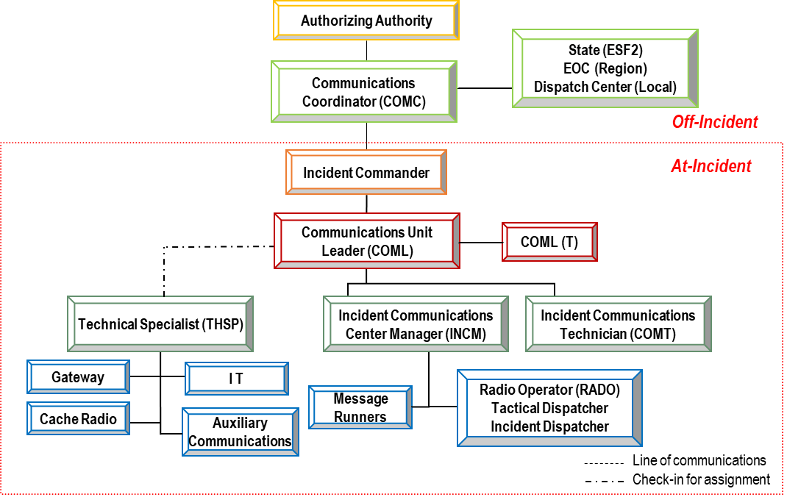

This page intentionally left blank

Interoperability Assets
Refer to regional Standard Operating Procedures (SOPs) for policies and procedures on asset usage.

General Rules of Use
- National Incident Management System – Implement an Incident Command System (ICS) compliant with the National Incident Management System (NIMS) when using any regional interoperability resource.
- National Response Framework – Use the appropriate ICS forms needed to document a given incident, in accordance with the National Response Framework (NRF).
- Plain Language – Avoid using radio codes, acronyms, and abbreviations as they may cause confusion between agencies. Ensure that all verbal requests for assistance or backup specify the reason for the request.
- Unit Identification – Announce your home agency prior to announcing your unit identifier during interoperable communication situations. (i.e., “Command, this is Henrico County Ambulance 26”).

Applies to Gateways
- Encryption – All encrypted radio users must operate in a “clear” mode when a gateway is used, unless otherwise arranged in advance. Never assume encryption carries across the gateway.
- Patching – Gateway devices should not patch Federal Communication Commission (FCC) frequencies to Military frequencies.
- Monitoring – The Incident Commander, or their designee, will ensure that each activated patch is monitored consistently while in use.
- Technical Support – Qualified gateway technical specialists (THSPs) or communications technicians (COMTs) must be available for on-scene support during the deployment of mobile gateways.
Applies to Radio Caches
- Charging – Cache radios must be fully charged and ready for immediate deployment when requested. Deployed equipment includes extra batteries and/or battery chargers to support extended deployments.
- Radio Identification - Each radio in a radio cache will have a unique identification number (e.g., serial number, etc.) for inventory tracking.
- Technical Support – Qualified radio cache THSPs or COMTs must be available for on-scene support during the deployment, if the requesting agency cannot act in this capacity.
- Equipment Return – The requesting agency is responsible for the return of any cache radios/MCUs/equipment in the condition that they were issued/received. Responsibilities for lost or damaged equipment lie with the appropriate agency as dictated by existing Memoranda of Agreement (MOAs).
Applies to Mobile Command Units (MCUs)
- Equipment Return – The requesting agency is responsible for the return of any MCU in the condition that it was received and/or as dictated by existing MOAs.
- Resource Modifications – The requesting agency is not allowed to change anything in the MCU without written permission of the owning agency. Should a modification need to be made, (e.g., changing an electric end) the requesting agency will incur costs of any modification/restoration.
- Operational Expenses – Responsibility for operational expenses should be decided upon ahead of time or within an MOU. National and State Interoperability Channels (MOTOBRIDGE)

National and State Interoperability Channels (MOTOBRIDGE)
The convention calls for frequency lists to show four digits after the decimal place, followed by either an “N” or a “W”, depending on whether the frequency is narrow or wide band. Mode refers to either “A” or “D” indicating analog or digital (e.g., Project 25) or "M" indicating mixed mode. All channels are shown as if programmed in a control station, mobile, or portable radio. Repeater and base stations must be programmed with the RX and TX reversed. Unless stated otherwise, all frequencies are MHz except CTCSS tones, which are in Hz.

VHF Low Band (State)
COMMUNICATIONS RESOURCE AVAILABILITY WORKSHEET  ICS 217A |  |  |  |  | Frequency Band  VHF Low Band |  |  | Description  Discipline Specific Channels
Channel Configuration | Channel Name/  Trunked Radio  System Talk Group | Eligible  Users | Mobile  RX Freq | N/  W | RX Tone/ NAC | Mobile  TX Freq | N/  W |  | TX  Tone/ NAC | Mode  A, D,  or M | Notes
Simplex | LCALLKS |  | 39.5800 | W | 156.7 | 39.5800 | W |  | 156.7
Simplex | LLAW1D |  | 39.7000 | W | 156.7 | 39.7000 | W |  | 156.7

VHF High Band (National)
COMMUNICATIONS RESOURCE AVAILABILITY WORKSHEET  ICS 217A |  |  |  |  | Frequency Band  VHF HIGH BAND |  |  | Description  Interoperable Tactical Channels
Channel Configuration | Channel Name/  Trunked Radio  System Talk Group | Eligible  Users | Mobile  RX Freq | N/  W |  | RX Tone/ NAC | Mobile  TX Freq |  | N/  W | TX  Tone/  NAC | Mode  A, D,  or M | Notes
Simplex | VCALL10 | Any Public Safety | 155.7525 | N |  | 156.7 | 155.7525 |  | N | 156.7 | A | Calling/  Hailing
Simplex | VTAC11 | Any Public Safety | 151.1375 | N |  | 156.7 | 151.1375 |  | N | 156.7 | A | Tactical Simplex
Simplex | VTAC12 | Any Public Safety | 154.4525 | N |  | 156.7 | 154.4525 |  | N | 156.7 | A
Simplex | VTAC13 | Any Public Safety | 158.7375 | N |  | 156.7 | 158.7375 |  | N | 156.7 | A
Simplex | VTAC14 | Any Public Safety | 159.4725 | N |  | 156.7 | 159.4725 |  | N | 156.7 | A

UHF Band (National)
COMMUNICATIONS RESOURCE AVAILABILITY WORKSHEET  ICS 217A |  |  |  | Frequency Band  UHF |  |  |  | Description  Interoperable Tactical Channels
Channel Configuration | Channel Name/  Trunked Radio  System Talk Group | Eligible  Users | Mobile  RX Freq |  | N/  W | RX  Tone/NAC | Mobile  TX Freq |  | N/  W | TX  Tone/ NAC | Mode  A, D,  or M | Notes
Duplex | UCALL40 | Any Public Safety | 453.2125 |  | N | 156.7 | 458.2125 |  | N | 156.7 | A
Simplex | UCALL40D | Any Public Safety | 453.2125 |  | N | 156.7 | 453.2125 |  | N | 156.7 | A
Duplex | UTAC41 | Any Public Safety | 453.4625 |  | N | 156.7 | 458.4625 |  | N | 156.7 | A
Simplex | UTAC41D | Any Public Safety | 453.4625 |  | N | 156.7 | 453.4625 |  | N | 156.7 | A
Duplex | UTAC42 | Any Public Safety | 453.7125 |  | N | 156.7 | 458.7125 |  | N | 156.7 | A
Simplex | UTAC42D | Any Public Safety | 453.7125 |  | N | 156.7 | 453.7125 |  | N | 156.7 | A
Duplex | UTAC43 | Any Public Safety | 453.8625 |  | N | 156.7 | 458.8625 |  | N | 156.7 | A
Simplex | UTAC43D | Any Public Safety | 453.8625 |  | N | 156.7 | 453.8625 |  | N | 156.7 | A

800 MHz Band (National)
COMMUNICATIONS RESOURCE AVAILABILITY WORKSHEET  ICS 217A |  |  |  |  | Frequency Band  800 MHZ |  |  | Description  Interoperable Tactical Channels
Channel Configuration | Channel Name/  Trunked Radio  System Talk Group | Eligible  Users | Mobile  RX Freq | N/  W |  | RX  Tone/ NAC | Mobile  TX Freq |  | N/  W | TX  Tone/ NAC | Mode  A, D,  or M | Notes
Duplex | 8CALL90 | Any Public Safety | 851.0125 | W |  | 156.7 | 806.0125 |  | W | 156.7 | A
Simplex | 8CALL90D | Any Public Safety | 851.0125 | W |  | 156.7 | 851.0125 |  | W | 156.7 | A
Duplex | 8TAC91 | Any Public Safety | 851.5125 | W |  | 156.7 | 806.5125 |  | W | 156.7 | A
Simplex | 8TAC91D | Any Public Safety | 851.5125 | W |  | 156.7 | 851.5125 |  | W | 156.7 | A
Duplex | 8TAC92 | Any Public Safety | 852.0125 | W |  | 156.7 | 807.0125 |  | W | 156.7 | A
Simplex | 8TAC92D | Any Public Safety | 852.0125 | W |  | 156.7 | 852.0125 |  | W | 156.7 | A
Duplex | 8TAC93 | Any Public Safety | 852.5125 | W |  | 156.7 | 807.5125 |  | W | 156.7 | A
Simplex | 8TAC93D | Any Public Safety | 852.5125 | W |  | 156.7 | 852.5125 |  | W | 156.7 | A
Duplex | 8TAC94 | Any Public Safety | 853.0125 | W |  | 156.7 | 808.0125 |  | W | 156.7 | A
Simplex | 8TAC94D | Any Public Safety | 853.0125 | W |  | 156.7 | 853.0125 |  | W | 156.7 | A

Mutual Aid Channels (Non-Federal)
The convention calls for frequency lists to show four digits after the decimal place, followed by either an “N” or a “W”, depending on whether the frequency is narrow or wide band. Mode refers to either “A” or “D” indicating analog or digital (e.g. Project 25). All channels are shown as if programmed in a portable or mobile radio. Repeater and base stations must be programmed with the RX and TX reversed. Unless stated otherwise, all frequencies are MHz except CTCSS tones, which are in kHz.

VHF Low Band Non-Federal National Interoperability Channels
VHF LOW BAND
COMMUNICATIONS RESOURCE AVAILABILITY WORKSHEET  ICS 217A |  |  |  |  |  | Frequency Band  VHF Low Band |  | Description  Statewide Channel Plan
 | Channel Configuration | Channel Name/ Trunked Radio System Talk Group | Eligible Users/ Assignments | Mobile Rx Freq | N/ W | Rx * Tone/ NAC | Mobile Tx Freq |  | N/ W | Tx Tone/ NAC | Mode  A, D, or M | Notes
1 |  | LLAW1 | Law Enforcement | 39.4600 | W | 156.7 | 45.8600 |  | W | 156.7 | A
2 |  | LLAW1D | Law Enforcement | 39.4600 | W | 156.7 | 39.4600 |  | W | 156.7 | A
3 |  | LFIRE2 | Fire (Proposed) | 39.4800 | W | 156.7 | 45.8800 |  | W | 156.7 | A
4 |  | LFIRE2D | Fire (Proposed) | 39.4800 | W | 156.7 | 39.4800 |  | W | 156.7 | A
5 |  | LLAW3 | Law Enforcement | 45.8600 | W | 156.7 | 39.4600 |  | W | 156.7 | A
6 |  | LLAW3D | Law Enforcement | 45.8600 | W | 156.7 | 45.8600 |  | W | 156.7 | A
7 |  | LFIRE4 | Fire (Proposed) | 45.8800 | W | 156.7 | 39.4800 |  | W | 156.7 | A
8 |  | LFIRE4D | Fire | 45.8800 | W | 156.7 | 45.8800 |  | W | 156.7 | A
Frequency 45.8800 MHz is pending FCC assignment for exclusive fire intersystem use.
* Default operation should be carrier squelch receive; CTCSS transmit. If the user can enable/disable without reprogramming the radio, the indicated CTCSS tone also could be programmed for receive, and the user instructed how and when to enable/disable.

VHF High Band Non-Federal National Interoperability Channels
COMMUNICATIONS RESOURCE AVAILABILITY WORKSHEET  ICS 217A |  |  |  |  | Frequency Band  VHF High Band |  |  | Description  Statewide Channel Plan
 | Channel Configuration | Channel Name/ Trunked Radio System Talk Group | Eligible Users/ Assignments | Mobile  Rx Freq | N/ W | Rx Tone/ NAC | Mobile Tx Freq |  | N/ W | Tx Tone/NAC | Mode  A, D, or M | Notes
1 | Simplex Base/Mobile | VCALL10 | Any Public Safety | 155.7525 |  | CSQ | Simplex |  |  | 156.7 | A +
2 |  | VTAC11** | Any Public Safety | 151.1375 |  | CSQ | Simplex |  |  | 156.7 | A +
3 |  | VTAC12** | Any Public Safety | 154.4525 |  | CSQ | Simplex |  |  | 156.7 | A +
4 |  | VTAC13 | Any Public Safety | 158.7375 |  | CSQ | Simplex |  |  | 156.7 | A +
5 |  | VTAC14 | Any Public Safety | 159.4725 |  |  | Simplex |  |  | 156.7 | A +
6 | Tactical Rptr | VTAC33**~ | Any Public Safety | 159.4725 |  | CSQ | 151.1375 |  |  | 136.5 | A
7 |  | VTAC34**~ | Any Public Safety | 158.7375 |  | CSQ | 154.4525 |  |  | 136.5 | A
8 |  | VTAC35~ | Any Public Safety | 159.4725 |  | CSQ | 158.7375 |  |  | 136.5 | A
9 |  | VTAC36**~ | Any Public Safety | 151.1375 |  | CSQ | 159.4725 |  |  | 136.5 | A
10 |  | VTAC37**~ | Any Public Safety | 154.4525 |  | CSQ | 158.7375 |  |  | 136.5 | A
11 |  | VTAC38~ | Any Public Safety | 158.7375 |  | CSQ | 159.4725 |  |  | 136.5 | A
** VTAC11-12, VTAC33, and VTAC36 may not be used in Puerto Rico or the USVI. +Default operation should be carrier squelch receive; CTCSS transmit. If the user can enable/disable without reprogramming the radio, the indicated CTCSS tone also could be programmed for receive, and the user instructed how and when to enable/disable. ~ VTAC33-38 recommended for deployable tactical repeater use only (FCC Station Class FB2T). ~ VTAC36-38 are preferred; VTAC33-35 should be used only when necessary due to interference. All frequencies are narrowband (11K2F3E) only. Radio channel names as listed in this Table are required.

VHF Non-Federal Inland Interoperability Channels
COMMUNICATIONS RESOURCE AVAILABILITY WORKSHEET  ICS 217A |  |  |  |  | Frequency Band  VHF Inland |  |  |  | Description  Statewide Channel Plan
 | Channel Configuration | Channel Name/ Trunked Radio System Talk Group | Eligible Users/ Assignments | Mobile  Rx Freq |  | N/ W | Rx * Tone/ NAC | Mobile Tx Freq |  | N/ W | Tx Tone/NAC | Mode  A, D, or M | Notes
1 | Tactical Rptr | VTAC17 | Any Public Safety | 161.8500 |  |  | CSQ | 157.2500 |  |  | 156.7 | A, D
2 | Simplex Base/ Mobile | VTAC17D | Any Public Safety | 161.8500 |  |  | CSQ | Simplex |  |  | 156.7 | A, D
*Default operation should be carrier squelch receive; CTCSS transmit. If the user can enable/disable without reprogramming the radio, the indicated CTCSS tone also could be programmed for receive, and the user instructed how and when to enable/disable.
Base stations: 50 watts max, antenna HAAT 400 feet max. Mobile stations: 20 watts max, antenna HAAT 15 feet max. These channels are for tactical use and may not be operated on board aircraft in flight. These channels use narrowband FM and are available only in certain inland areas at least 100 miles from a major waterway. These channels use the same frequencies as VHF Marine channel 25, which uses wideband FM. Use only where authorized. See map on next page. In these authorized areas, interoperability communications have priority over grandfathered public coast and public safety licensees.

UHF Non-Federal National Interoperability Channels
COMMUNICATIONS RESOURCE AVAILABILITY WORKSHEET  ICS 217A |  |  |  |  | Frequency Band  UHF |  |  | Description  Statewide Channel Plan
 | Channel Configuration | Channel Name/Trunked Radio System Talk Group | Eligible Users/  Assignments | Rx Freq |  | Rx Tone/NAC | Tx Freq |  | Tx Tone/NAC | Mode  A, D, or M | Notes
1 | Repeater Pair | UCALL40 | Any Public Safety | 453.2125 |  | CSQ | 458.2125 |  | 156.7 | A
2 | Simplex Base/Mobile | UCALL40D | Any Public Safety | 453.2125 |  | CSQ | Simplex |  | 156.7 | A
3 | Repeater Pair | UTAC41 | Any Public Safety | 453.4625 |  | CSQ | 458.4625 |  | 156.7 | A
4 | Simplex Base/Mobile | UTAC41D | Any Public Safety | 453.4625 |  | CSQ | Simplex |  | 156.7 | A
5 | Repeater Pair | UTAC42 | Any Public Safety | 453.7125 |  | CSQ | 458.7125 |  | 156.7 | A
6 | Simplex Base/Mobile | UTAC42D | Any Public Safety | 453.7125 |  | CSQ | Simplex |  |  | A
7 | Repeater Pair | UTAC43 | Any Public Safety | 453.8625 |  | CSQ | 458.8625 |  | 156.7 | A
8 | Simplex Base/Mobile | UTAC43D | Any Public Safety | 453.8625 |  | CSQ | Simplex |  |  | A
CTCSS 156.7 Hz(5A) transmit and receive. All channels on this page are NARROWBAND only. Limited to 3 watts ERP North of Line A or East of Line C.

Regional Interoperability Information
Northeast Kansas Mutual Aid Channels
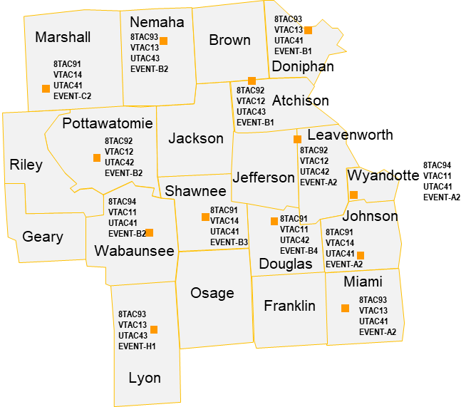

Southeast Kansas Mutual Aid Channels
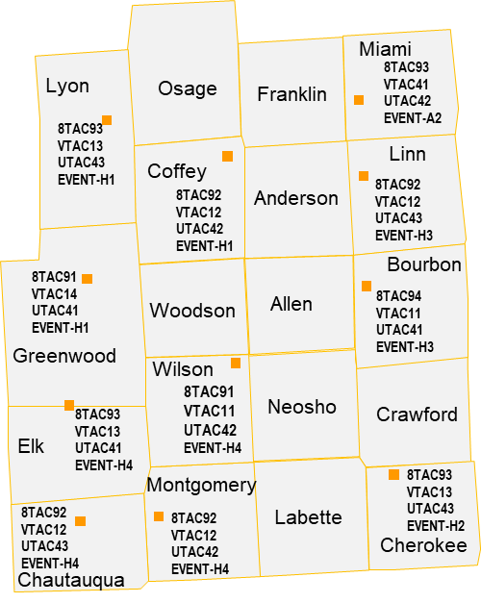

North Central Kansas Mutual Aid Channels
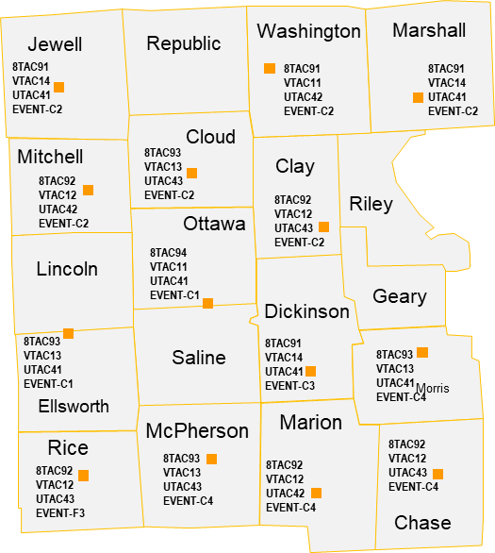

South Central Kansas Mutual Aid Channels
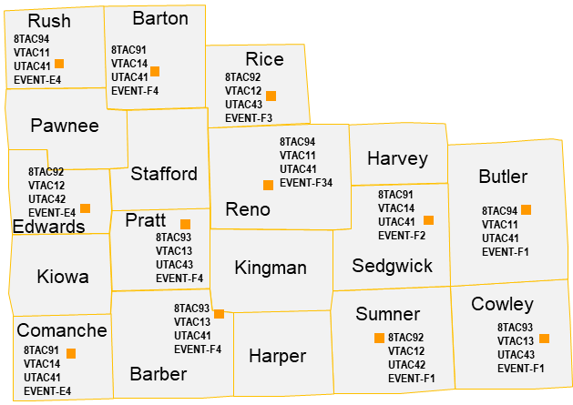
Northwest Kansas Mutual Aid Channels
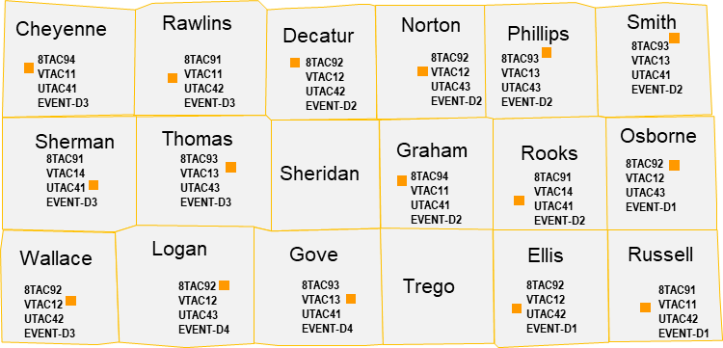

Southwest Kansas Mutual Aid Channels
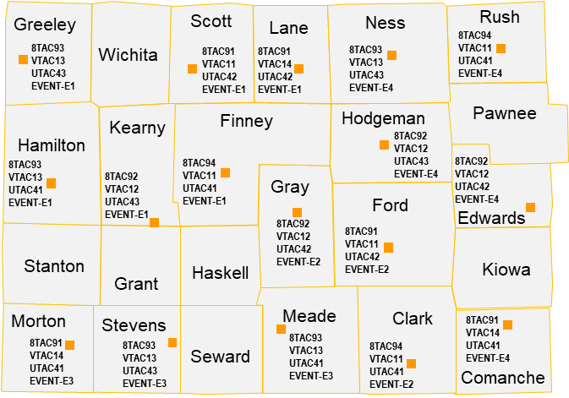

Kansas Homeland Security Regions and KDOT Tower Sites
Kansas is divided into 14 radio zones aligned with the seven Homeland Security Regions.
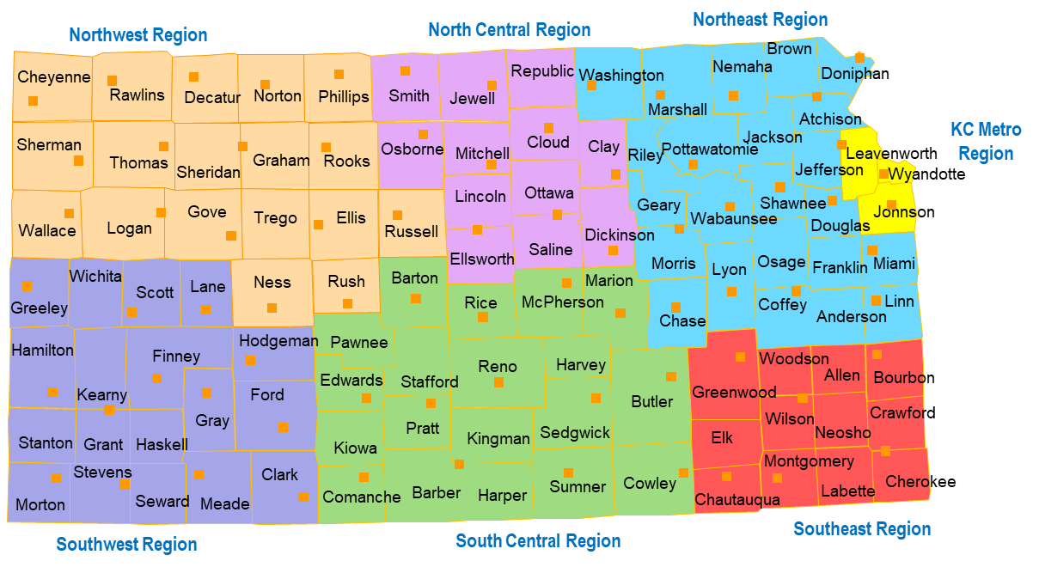

County | Zone | County | Zone | County | Zone | County | Zone
Allen | SE1 | Finney | SW12 | Logan | NW14 | Rooks | NW13
Anderson | NE4 | Ford | SW11 | Lyon | NE4 | Rush | NW13
Atchison | NE6 | Franklin | NE4 | Marion | SC9 | Russel | NW13
Barber | SC10 | Geary | NE5 | Marshall | NE6 | Saline | NC8
Barton | SC9 | Gove | NW14 | McPherson | SC9 | Scott | SW12
Bourbon | SE1 | Graham | NW13 | Meade | SW11 | Sedgwick | SC10
Brown | NE6 | Grant | SW11 | Miami | NE4 | Seward | SW11
Butler | SC10 | Gray | SW11 | Mitchell | NC7 | Shawnee | NE5
Chase | NE4 | Greeley | SW12 | Montgomery | SE2 | Sheridan | NW14
Chautauqua | SE2 | Greenwood | SE2 | Morris | NE4 | Sherman | NW14
Cherokee | SE1 | Hamilton | SW12 | Morton | SW11 | Smith | NC7
Cheyenne | NW14 | Harper | SC10 | Nemaha | NE6 | Stafford | SC9
Clark | SW11 | Harvey | SC9 | Neosho | SE1 | Stanton | SW11
Clay | NC8 | Haskell | SW11 | Ness | NW13 | Stevens | SW11
Cloud | NC7 | Hodgeman | SW11 | Norton | NW13 | Sumner | SC10
Coffey | NE4 | Jackson | NE6 | Osage | NE4 | Thomas | NW14
Comanche | SC10 | Jefferson | NE6 | Osborne | NC7 | Trego | NW13
Cowley | SC10 | Jewell | NC7 | Ottawa | NC8 | Wabaunsee | NE5
Crawford | SE1 | Johnson | KC3 | Pawnee | SC9 | Wallace | NW14
Decatur | NW14 | Kearny | SW12 | Phillips | NW13 | Washington | NE6
Dickenson | NC8 | Kingman | SC10 | Pottawatomie | NE6 | Wichita | SW12
Doniphan | NE6 | Kiowa | SC10 | Pratt | SC10 | Wilson | SE2
Douglas | NE5 | Labette | SE1 | Rawlins | NW14 | Woodson | SE2
Edwards | SC9 | Lane | SW12 | Reno | SC9 | Wyandotte | KC3
Elk | SE2 | Leavenworth | KC3 | Republic | NC7
Ellis | NW13 | Lincoln | NC8 | Rice | SC9
Ellsworth | NC8 | Linn | NE4 | Riley | NE6
Regional Talkgroups Information
- Although regional talkgroups are organized by zone, they are available for use statewide.
- Each zone’s talkgroups are set up identical to correspond with the position of the channel selector on the radio (the first 8 channels are the same in all zones).
- There are 16 positions on the radio’s channel selector knob. Note: That is not the case with all equipment, especially mobile units).
- The channel is named with the region and zone indicator and then the discipline. Example: SE1-PSAP is the Southeast Region, Zone 1, PSAP talkgroup.
- The KHP Event channels in each zone are specific to certain towers.
- Use the county listing to find which zone you need to be in to communicate within the appropriate talkgroup, then set your radio to that zone and turn the selector knob to get to the correct channel
- Listing of the channels in each zone:
  - 1-PSAP
  - 2-MED (Hospitals/Medical)
  - 3-TAC 1 (Tactical)
  - 4-TAC 2 (Tactical)
  - 5-AES (Encrypted)
  - 6-KDEM-CALL (KDEM Calling)
  - 7-NWS (National Weather Service for the region specified)
  - 8-Channel 8 and on are KHP event channels specific to that zone

Regional Talkgroups: Southeast, Kansas City Metro, Northeast, North Central
Ch | SE1 | SE2 | KC3 | NE4 | NE5 | NE6 | NC7 | NC8
1 | SE1-PSAP | SE2-PSAP | KC3-PSAP | NE4-PSAP | NE5-PSAP | NE6-PSAP | NC7-PSAP | NC8-PSAP
2 | SE1-MED | SE2-MED | KC3-MED | NE4-MED | NE5-MED | NE6-MED | NC7-MED | NC8-MED
3 | SE1-TAC 1 | SE2-TAC 1 | KC3-TAC 1 | NE4-TAC 1 | NE5-TAC 1 | NE6-TAC 1 | NC7-TAC 1 | NC8-TAC 1
4 | SE1-TAC 2 | SE2-TAC 2 | KC3-TAC 2 | NE4-TAC 2 | NE5-TAC 2 | NE6-TAC 2 | NC7-TAC 2 | NC8-TAC 2
5 | SE1-AES | SE2-AES | KC3-AES | NE4-AES | NE5-AES | NE6-AES | NC7-AES | NC8-AES
6 | KDEM-CALL | KDEM-CALL | KDEM-CALL | KDEM-CALL | KDEM-CALL | KDEM-CALL | KDEM-CALL | KDEM-CALL
7 | NWS WICH | NWS WICH | NWS TOP | NWS TOP | NWS TOP | NWS TOP | NWS GOOD | NWS GOOD
8 | H-EVNT-1 | H-EVNT-1 | A-EVNT-1 | A-EVNT-1 | B-EVNT-1 | B-EVNT-1 | C-EVNT-1 | C-EVNT-1
9 | H-EVNT-2 | H-EVNT-2 | A-EVNT-2 | B-EVNT-1 | B-EVNT-2 | B-EVNT-2 | C-EVNT-2 | C-EVNT-2
10 | H-EVNT-3 | H-EVNT-3 | A-EVNT-3 | B-EVNT-2 | B-EVNT-3 | B-EVNT-3 | C-EVNT-3 | C-EVNT-3
11 |  |  |  | B-EVNT-3 | C-EVNT-1 | C-EVNT-1 | D-EVNT-1
12 |  |  |  | C-EVNT-1 | C-EVNT-2 | C-EVNT-2 | D-EVNT-2
13 |  |  |  | C-EVNT-2 | C-EVNT-3 | C-EVNT-3 | D-EVNT-3
14 |  |  |  | H-EVNT-1
15 |  |  |  | H-EVNT-2
16 |  |  |  | H-EVNT-3

Regional Talkgroups: South Central, Southwest, Northwest
Ch | SC9 | SC10 | SW11 | SW12 | NW13 | NW14
1 | SC9-PSAP | SC10-PSAP | SW11-PSAP | SW12-PSAP | NW13-PSAP | NW14-PSAP
2 | SC9-MED | SC10-MED | SW11-MED | SW12-MED | NW13-MED | NW14-MED
3 | SC9-TAC 1 | SC10-TAC 1 | SW11-TAC 1 | SW12-TAC 1 | NW13-TAC 1 | NW14-TAC 1
4 | SC9-TAC 2 | SC10-TAC 2 | SW11-TAC 2 | SW12-TAC 2 | NW13-TAC 2 | NW14-TAC 2
5 | SC9-AES | SC10-AES | SW11-AES | SW12-AES | NW13-AES | NW14-AES
6 | KDEM-CALL | KDEM-CALL | KDEM-CALL | KDEM-CALL | KDEM-CALL | KDEM-CALL
7 | NWS WICH | NWS WICH | NWS DODG | NWS DODG | NWS GOOD | NWS GOOD
8 | C-EVNT-1 | E-EVNT-1 | E-EVNT-1 | E-EVNT-1 | D-EVNT-1 | D-EVNT-1
9 | C-EVNT-2 | E-EVNT-2 | E-EVNT-2 | E-EVNT-2 | D-EVNT-2 | D-EVNT-2
10 | E-EVNT-1 | E-EVNT-3 | E-EVNT-3 | E-EVNT-3 | D-EVNT-3 | D-EVNT-3
11 | E-EVNT-2 | F-EVNT-1 |  |  | E-EVNT-1
12 | E-EVNT-3 | F-EVNT-2 |  |  | E-EVNT-2
13 | F-EVNT-1 | F-EVNT-3 |  |  | E-EVNT-3
14 | F-EVNT-2 | YODER
15 | F-EVNT-3
16 | YODER
Statewide Talkgroups Information
- Use of the statewide talkgroups listed in the table below must be requested through the Statewide Interoperability Coordinator (SWIC)/Office of Emergency Communications.
- Statewide ICS talkgroups -- may be used for multiagency events if expands beyond a sub-region (e.g. Wildland Fire).
- Mutual Aid (M/A) 800 and 700 MHz – Using the national interoperability channels listed in the table below, MOTOBRIDGE can connect or “patch” these channels between disparate radio systems.
- State -- State agency owned talkgroups that can be used for a major event.
  - Kansas Turnpike Authority (KTA)
  - State Fire Marshall (SFM)
  - Wildlife & Parks (W&P)

Statewide Talkgroups
Ch | Zone 1-ICS | Zone 2-ICS | South ERT-ICS | North ERT-ICS | M/A 800 | M/A 700 * | M/A 700 ** | STATE
1 | KDEM CAL | KDEM CALL | ICS-1 | ICS-11 | 8CALL90 | 7CALL50 | 7CALL70 | KTA South
2 | ICS-1 | ICS-11 | ICS-2 | ICS-12 | 8CALL90D | 7CALL50D | 7CALL70D | KTA North
3 | ICS-2 | ICS-12 | ICS-3 | ICS-13 | 8TAC91 | 7TAC51 | 7TAC71 | KTA Evt 1
4 | ICS-3 | ICS-13 | ICS-4 | ICS-14 | 8TAC91D | 7TAC51D | 7TAC71D | KTA Evt-2
5 | ICS-4 | ICS-14 | ICS-5 | ICS-15 | 8TAC92 | 7TAC52 | 7TAC72 | KTA Evt-3
6 | ICS-5 | ICS-15 | ICS-6 | ICS-16 | 8TAC92D | 7TAC52D | 7TAC72D | SFM INV-1
7 | ICS-6 | ICS-16 | ICS-7 | ICS-17 | 8TAC93 | 7TAC53 | 7TAC73 | SFM HZM-1
8 | ICS-7 | ICS-17 | ICS-8 | ICS-18 | 8TAC93D | 7TAC53D | 7TAC73D | SFM SAR-1
9 | ICS-8 | ICS-18 | ICS-9 | ICS-19 | 8TAC94 | 7TAC54 | 7TAC74 | SFM CMD-1
10 | ICS-9 | ICS-19 | ICS-10 | ICS-20 | 8TAC94D | 7TAC54D | 7TAC74D | SFM TAC-1
11 | ICS-10 | ICS-20 | COMMON-1 | COMMON-5 |  | 7TAC55 | 7TAC75 | W&P Evt 1
12 | COMMON-1 | COMMON-5 | COMMON-2 | COMMON-6 |  | 7TAC55D | 7TAC75D | W&P Evt 2
13 | COMMON-2 | COMMON-6 | COMMON-3 | COMMON-7 |  | 7TAC56 | 7TAC76 | W&P Evt 3
14 | COMMON-3 | COMMON-7 | COMMON-4 | COMMON-8 |  | 7TAC56D | 7TAC76D | W&P Evt 4
15 | COMMON-4 | COMMON-8 | COMU | COMU |  |  |  | W&P Evt 5
16 | COMU | COMU |  |  |  |  |  | MERG-4
 |  |  |  |  | * Denotes Primary Calling Channel
 |  |  |  |  | ** Denotes Secondary Calling Channel

Plain Language Words and Phrases
Plain Language | Meaning or Usage
Affirmative | Yes.
At scene | Used when a unit arrives at the scene of an incident.
Available | Used when a unit is ready for a new assignment or can return to quarters.
Available at residence | Used by administrative or staff personnel to indicate they are available and on-call at their residence.
Available at scene | Used when a unit is still committed to an incident but could be dispatched to a new emergency if needed.
Burning operation | Used to indicate that a fire is started intentionally, usually by the fire department, to eliminate burnable fuels in order to prevent the spread of wildfires.
Can handle | Used when the amount of equipment needed to handle the incident is on scene.  Ex: "San Luis, Battalion 3412 can handle with units at scene".
Call ______ by phone | Self-explanatory
Copy, copies | Used to acknowledge message received. Unit radio ID must also be used. Ex: "Engine 2563 copies".
Disregard last message | Self-explanatory.
Emergency traffic | Term used to gain control of a radio frequency to report an emergency. All other radio users will refrain from using that frequency until cleared for use by a dispatcher or incident commander.
Emergency traffic only | Used by radio users to confine all radio traffic to an emergency in progress or a new incident.
En route | Normally used by administrative or staff personnel to designate destination. En route is not a substitute for responding.
Fire under control | Used by the fire department to indicate that a fire is no longer increasing in size or complexity and no additional resources are required to extinguish it.
In quarters, with station name or number | Used to indicate that a unit is in a station. Ex: “Oroville, Engine 2176 in quarters, Jarbo Gap Station”.
In service | Indicates the unit is operating, but not in response to a dispatch. Ex: “San Andreas, Engine 4460, in service, fire prevention inspections”.
Is ______ available for a phone call? | Self-explanatory.
Loud and clear | A signal report describing signal strength and readability
Negative | No.
Out of service | Indicates unit is out of service. When the unit is back in service a phrase like the following example should be used: Ex: “Redding, Engine 2460, out of service, [give reason] [provide duration].”
Repeat | Used to ask for a transmission to be spoken again.
Report on conditions | Used by the fire department for a unit (usually the first arriving) to describe the incident in a concise manner, allowing other responders and dispatch to comprehend the incident.
Respond, Responding | Used during dispatch to direct units to proceed to an incident or to refer to units proceeding to an incident. Ex: “Engine 3365, respond…: or “St. Helena, Engine 1475 responding.”
Resume normal [radio] traffic | Self-explanatory.
Return to _____ | Normally used to direct units that are available to a station or other location.
Stand by | Self-explanatory.
Stop transmitting | Self-explanatory.
Uncovered | Indicates a unit is not in service, because there are no personnel to operate it.
Unreadable | Used when signal received is not clear. Try to add the specific trouble. Ex: “Unreadable, background noise.”
Vehicle registration check | Self-explanatory.
Weather | Self-explanatory.
What is your location? | Self-explanatory.

Phonetic Alphabet Standards
Letter | Military | Public Safety | Morse Code | Nautical | Sign
A | Alpha | Adam | • ▬
B | Bravo | Boy | ▬ • • •
C | Charlie | Charlie | ▬ • ▬ •
D | Delta | David | ▬ • •
E | Echo | Edward | •
F | Foxtrot | Frank | • • ▬ •
G | Golf | George | ▬ ▬ •
H | Hotel | Henry | • • • •
I | India | Ida | • •
J | Juliet | John | • ▬ ▬ ▬
K | Kilo | King | ▬ • ▬
L | Lima | Lincoln | • ▬ • •
M | Mike | Mary | ▬ ▬
N | November | Nora | ▬ •
O | Oscar | Ocean | ▬ ▬ ▬
P | Papa | Paul | • ▬ ▬ •
Q | Quebec | Queen | ▬ ▬ • ▬
R | Romeo | Robert | • ▬ •
S | Sierra | Sam | • • •
T | Tango | Tom | ▬
U | Uniform | Union | • • ▬
V | Victor | Victor | • • • ▬
W | Whiskey | William | • ▬ ▬
X | X-ray | X-Ray | ▬ • • ▬
Y | Yankee | Young | ▬ • ▬ ▬
Z | Zulu | Zebra | ▬ ▬ • •

This page intentionally left blank

FirstNet Incident Communications Support
Deployable Communications Support – Incident Response, Planned Events
First Responder Network Authority (FirstNet) customers can request emergent incident support through Customer Care:
800-574-7000 (This is a 24/7/365 number).
- Not every incident requires deploying a full site on wheels. A trailer, tethered drone, or network optimization may address your requirements. If you believe you will require additional FirstNet coverage or capacity, call for support.
- In a large incident, you may request the State EOC (SEOC) ESF-2 desk to assist with your request for coverage enhancements or deployment of additional handsets/hotspot devices.
- For planned events or demonstration equipment, you should submit your request 30 days in advance. A FirstNet deployable request form is available from AT&T or the Emergency Communications Section (ECS) within KDEM. An example is provided on the next page.
- Best Practice: Coordinate your planned event request with the ECS team through KDEM.
Interoperability Applications
Secure, vulnerability tested apps are offered through the FirstNet App catalog (https://apps.firstnet.att.com/) Access requires a registered user log-in. Applications in the catalog are distributed through the Google Play and Apple App stores.
While the list of certified apps is growing, the First Responder Network Authority does NOT recommend specific apps, leaving the choice to the jurisdiction to select the most appropriate apps for their requirements. Statewide and regional governance, and training and exercise will identify the best applications for public safety.
As of October 2020, applications are available to help with:
- Situational Awareness
- Common Operating Picture
- Communications (push to talk over LTE)
- Information Management (Field Operations Guide)
- Public Interaction
- CAD Solutions
- Field Collaboration
- Cloud Solutions
- Device Management (https://apps.firstnet.att.com/ )

FirstNet Customer Deployable Request: Planned/Demo Event
Choose the type of deployable request: | Planned (transmitting) or Demo (non-transmitting)
Contact Information
Agency FAN / PIN | Fill in only if requestor can provide this information, if not, skip this field
Requestor/Caller | Joe Smith
Phone | (426) 123-4567
Agency; currently a FN subscriber | Honey Police Dept; yes/no
Primary Contact | Lt. Buck Johnson | AT&T Employee: Y N | ATTUID:
Phone | (426) 765-9876
E-Mail Address | b.johnson@honeypd.com
Secondary Contact | Deputy James Jill | AT&T Employee: Y N | ATTUID:
Phone | (426) 876-2834
Email Address | j.jill@honeypd.com
If Requestor or Contact is an AT&T Employee, ensure they will be on-call 24/7 until event is complete
Event Information
From today’s date, is the event < 30days out? If so, please provide justification.
Name of the Event | International Fire Chief Association
Description of the Event | Tradeshow, conference, etc.
Event Date(s) | January 1 – January 7, 2018
Event daily start/end times | 8am-6pm daily
Event Location & Address  (as specific as possible – i.e. room number) | Hilton Convention Center – Room 1B231 (123 Main St, Las Vegas, NV 89132)
Planned Command Center | Yes – No – Don’t know (if yes, include location)
County | Required for e911
Total Expected Event Attendance | 12,345
Total Expected FirstNet Subscribers | 123
Are there any VIP attending? | Federal, State, City officials, high ranking military officers, etc.

Deployable Information
Main purpose of deployable? | Improve Data, Streaming, Voice coverage for FN subscribers; Demo-only
Is coverage/deadspot(s) a concern? | Yes – No – Don’t know
Does the customer have Band 14 devices? | Yes – No – Don’t know
Describe any data-intensive actions used specifically for public safety? | Streaming video, webcams, etc.
Provide SATColt SETUP date/time? | December 31 @ 12pm
Provide SATColt TEARDOWN date/time? | January 8 @ 12pm
Proposed Location of Deployable
Address/local cross streets/  lat-long coordinates: | 123 NW Shaw St, Honey, TX 52342
Public or Private Property? | Public or Private
On-site requirements/limits: | Does SATColt driver need to contact anyone once arrived?
Will security be provided for the asset? | Yes
Clear access to the southern sky? | Yes
Is there level and clear 100ft x 100ft area for the deployable? | Yes
On-site Arrival Contact (Provide 24/7 on-call contact)
(Title/Rank) Primary Name: | Sgt. John Swansen | Phone | xxx-xxx-xxxx
(Title/Rank) Secondary Name: | Sgt. Clint Kleenex | Phone | xxx-xxx-xxxx
Agency: | Honey Police Dept
FirstNet Status
There are several ways to monitor or obtain network status.
- FirstNet Local Control portal (registered users)
- Sign-up for network alerts (through the FirstNet Local Control portal)
- If activated, the State or regional Emergency Operations Centers ESF-2 (Communications) desk may have information
Local Control has an interactive Network Status Tool providing public safety communications professionals with visibility into established network coverage quality, along with overlays of weather, traffic, fire, wind, flash flood, and network alerts. Public safety communications professionals can request both emergency and planning assistance when planning for and/or responding to an event that may have heavy network demands or affects the network itself.
Uplift Portal and Incident Management
Local Control is FirstNet’s web portal for Public Safety Entities (PSEs). In Local Control, PSE communications administrators manage their entity’s access to and use of the FirstNet Network by managing users, devices, solutions, apps, services and billing for their organization.
During an incident, certain users can be temporarily uplifted to assure their access to services is prioritized over other public safety users. This is a temporary level which can only be performed by staff who are designated beforehand. Uplift lasts for 24 hours.
For Incident Managers, the Uplift Request Tool is used to uplift wireless numbers on FirstNet. Users assigned as uplift managers can create and update uplift requests, manage groups, view wireless number details, and create and download reports. This is particularly important during an incident when multiple agencies will convene upon an incident, including primary and extended primary users (e.g. public works, utilities, debris removal vehicles, etc.).
Only users who've been set up as an uplift manager for their organization can access the Uplift Request Tool, so it’s important to learn more about this important feature by reaching out to your Statewide Interoperability Coordinator, COML, COMT, or First Responder Network Authority Regional Advisor. You may also visit the FirstNet.com training portal at: https://training.firstnet.att.com/.
In the future, certain applications on the FirstNet app catalog will have the ability to dynamically change prioritization level, providing always-connected apps, across all users – primary and extended primary – with App Priority. This will be helpful when it’s not time feasible to uplift (e.g., Extended primary personnel are performing critical activities in preparation for a large weather event).

Local Control Portal: Public Safety Entity Network Status View.
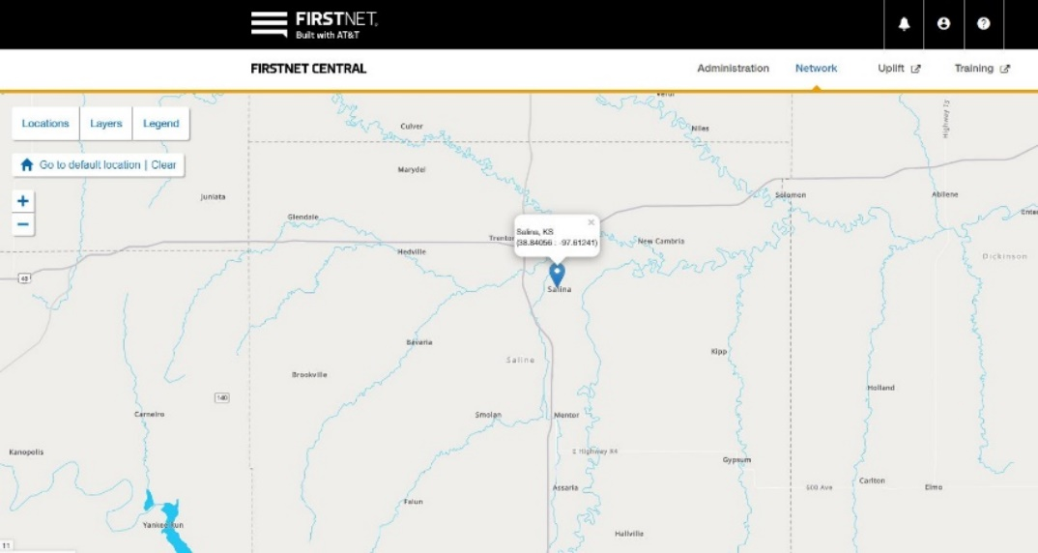

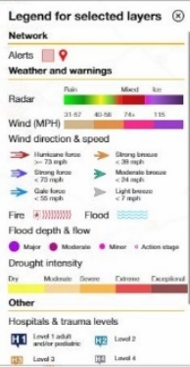

This page intentionally left blank

Reference Materials
Reference Sources
- SAFECOM. https://www.cisa.gov/safecom
The National Emergency Communications Plan (NECP) is a strategic plan that sets goals and identifies key national priorities to enhance governance, planning, technology, training and exercises, and disaster communications capabilities. The NECP provides recommendations, including milestones, to help emergency response providers and relevant government officials make measurable improvements in emergency communications over the next three years.
- National Public Safety Telecommunications Council (NPSTC). http://www.npstc.org
NPSTC is a volunteer federation of public safety organizations, whose mission is to improve public safety communications and interoperability through collaborative leadership. NPSTC's members are the organizations representing fire, EMS, law enforcement, transportation, and other telecommunications organizations.
- NIFOG. https://www.dhs.gov/publication/fog-documents
The National Interoperability Field Operations Guide (NIFOG) is a technical reference for emergency communications planning and for radio technicians responsible for radios that will be used in disaster response. The NIFOG includes rules and regulations for use of nationwide and other interoperability channels, table of frequencies and standard channel names, and other reference material; formatted as a pocket-sized guide for radio technicians to carry with them.
- Federal Emergency Management Agency (FEMA). http://www.fema.gov
The Department of Homeland Security Target Capability List (TCL) describes the capabilities related to the four homeland security mission areas: Prevent, Protect, Respond, and Recover. It defines and provides the basis for assessing preparedness. It also establishes national guidance for preparing the Nation for major all-hazards events, such as those defined by the National Planning Scenarios.
- NIMS Integration Center. http://www.fema.gov/emergency/nims/
The National Incident Management System (NIMS) provides a systematic, proactive approach to guide departments and agencies at all levels of government, nongovernmental organizations, and the private sector to work seamlessly to prevent, protect against, respond to, recover from, and mitigate the effects of incidents, regardless of cause, size, location, or complexity, in order to reduce the loss of life and property and harm to the environment.
- First Responder Network Authority (FirstNet). http://www.firstnet.com
The FirstNet mission is to deploy, operate, maintain, and improve the first high-speed, nationwide wireless broadband network dedicated to public safety. This reliable, highly secure, interoperable, and innovative public safety communications platform will bring 21st century tools to public safety agencies and first responders, allowing them to get more information quickly and helping them to make faster and better decisions.

This page intentionally left blank

Incident Command System (ICS) Communication Forms
This appendix contains forms for incident command system (ICS) planning. If you don’t have these forms available for your use, they can be found at the following website:
https://training.fema.gov/icsresource/icsforms.aspx

This page intentionally left blank

Incident Radio Communications Plan (ICS Form 205)
1. Incident Name: |  |  |  |  | 2. Date/Time Prepared:  Date From: Date To:  Time From: Time To: |  |  |  |  | 3. Operational Period:  Date From: Date To:  Time From: Time To:
4. Basic Radio Channel Use:
Zone Grp. | Ch # | Function |  | Channel Name/  Trunked Radio System Talkgroup |  |  | Assignment | RX Freq  N/ W | RX  Tone/  NAC |  | RX Freq  N/ W | TX  Tone/  NAC | Mode (A, D, or M) | Remarks
 |  |  |  |  |  |  |  | xxx.xxxx | xxx.x |  | xxx.xxxx | xxx.x
5. Special Instructions:
6. Prepared by (Communications Unit Leader):
Name: Signature:
ICS 205 |  |  | IAP Page |  |  | Date/Time:

Instructions for Completing the Incident Radio Communications Plan (ICS 205)
ITEM # | ITEM TITLE | INSTRUCTIONS
1. | Incident Name | Print the name assigned to the incident.
2. | Date/Time Prepared | Enter date (month, day, year) and time prepared (24-hour clock).
3. | Operational Period  Date/Time | Enter the date and time. Interval for which the Radio Communications Plan applies. Record the start time and end time and include date(s).
4. | Basic Radio Channel Utilization System/Cache | Enter the radio cache system(s) assigned and used on the incident (e.g., Boise Cache, FIREARMS, Region 5 Emergency Cache, etc).
 | Channel Number | Enter the radio channel numbers assigned.
 | Function | Enter the function each channel number is assigned (i.e., command, support, division tactical, and ground-to-air).
 | Frequency | Enter the radio frequency tone number assigned to each specified function (e.g., 153.4000).
 | Assignment | Enter the ICS organization assigned to each of the designated frequencies (e.g., Branch I, Division A).
 | Remarks | This section should include narrative information regarding special situations
5. | Prepared By | Enter the name of the Communications Unit Leader preparing the form.
Purpose: The Incident Radio Communications Plan provides in one location information on all radio frequencies assignments for each operational period. The plan is a summary of information obtained from the Radio Requirement Worksheet (ICS Form 216) and the Radio Frequency Assignment Worksheet (ICS Form 217). Information from the Radio Communications Plan on frequency assignment is normally placed on the appropriate Assignment List (ICS Form 204).
Preparation: The Incident Radio Communications Plan is prepared by the Communications Unit Leader and given to the Planning Section Chief.
Distribution: The Incident Radio Communications Plan is duplicated and given to all recipients of the Incident Objectives form including the Incident Communications Center. Information from the plan is placed on Assignment List.

This page intentionally left blank

ICS 205A Communications List
1. Incident Name: |  |  |  | 2. Operational Period:  Date From: Date To:  Time From: Time To:
3. Basic Local Communications Information:
Incident Assignment Position |  | Name (Alphabetized) |  |  | Method(s) of Contact  (phone, pager, cell, etc.)
4. Prepared by: Name: ___________Position/Title: ________Signature: __________
ICS 205A | IAP Page _____ |  | Date/Time:
Instructions for Completing the Communications List (ICS 205A)
BLOCK TITLE | INSTRUCTIONS
Incident Name | Enter the name assigned to the incident.
Operational Period  - Date and Time From  - Date and Time To | Enter the start date (month/day/year) and time (using the 24-hour clock) and end date and time for the operational period to which the form applies.
Basic Local Communications Information  - Incident Assigned Position  - Name  - Method(s) of Contact (phone, pager, cell, etc.) | Enter the communications methods assigned and used for personnel by their assigned ICS position.  Enter the ICS organizational assignment.  Enter the name of the assigned person.  For each assignment, enter the radio frequency and contact number(s) to include area code, etc. If applicable, include the vehicle license or ID number assigned to the vehicle for the incident (e.g., HAZMAT 1, etc.).
Prepared by:  - Name  - Position/Title  - Signature  - Date/Time | Enter the name, ICS position, and signature of the person preparing the form. Enter date (month/day/year) and time prepared (24-hour clock
Purpose: The Communications List (ICS 205A) records methods of contact for incident personnel. While the Incident Radio Communications Plan (ICS 205) is used to provide information on all radio frequencies down to the Division/Group level, the ICS 205A indicates all methods of contact for personnel assigned to the incident (radio frequencies, phone numbers, pager numbers, etc.), and functions as an incident directory.
Preparation: The ICS 205A can be filled out during check-in and is maintained and distributed by Communications Unit personnel. This form should be updated each operational period.
Distribution: The ICS 205A is distributed within the ICS organization by the Communications Unit and posted as necessary. All completed original forms must be given to the Documentation Unit. If this form contains sensitive information such as cell phone numbers, it should be clearly marked in the header that it contains sensitive information and is not for public release.
Notes:
- The ICS 205A is an optional part of the Incident Action Plan (IAP)
- This optional form is used in conjunction with the ICS 205.
- If additional pages are needed, use a blank ICS 205A and repaginate as needed.

This page intentionally left blank

Communications Resource Availability Worksheet (ICS 217A)
COMMUNICATIONS RESOURCE AVAILABILITY WORKSHEET  Form 217A |  |  |  |  |  |  | Frequency Band |  |  |  | Description
Channel Configuration | Channel Name/  Trunked Radio System Talk Group | Eligible  Users | Mobile  RX Freq | N/W | RX  Tone/NAC | Mobile  TX Freq |  | N/W | TX  Tone/NAC | Mode  A, D,  or M |  | Notes
A=Analog, D=Digital, M=Mixed Mode; N=Narrowband, W=Wideband
The convention calls for frequency lists to show four digits after the decimal place, followed by either an “N” or a “W”, depending on whether the frequency is narrow or wide band. Mode refers to either “A” or “D” indicating analog or digital (e.g. Project 25). All channels are shown as if programmed in a portable or mobile radio. Repeater and base stations must be programmed with the RX and TX reversed.

Sample ICS 217A
COMMUNICATIONS RESOURCE AVAILABILITY WORKSHEET  Form 217A |  |  |  |  |  | Frequency Band |  |  |  | Description
Channel Configuration | Channel Name/  Trunked Radio System Talk Group | Eligible  Users | Mobile  RX Freq | N/W | RX  Tone/NAC |  | Mobile  TX Freq | N/W | TX  Tone/NAC |  | Mode  A, D,  or M | Notes
List – Identify Tactical Nets |  | Ops
List – Identify Command Nets |  | CMND & General Staff
List – Identify Air-to-Ground Nets |  | Air Ops & Ops
List – Identify Dispatch Nets |  | Initial Attack
A=Analog, D=Digital, M=Mixed Mode; N=Narrowband, W=Wideband
The convention calls for frequency lists to show four digits after the decimal place, followed by either an “N” or a “W”, depending on whether the frequency is narrow or wide band. Mode refers to either “A” or “D” indicating analog or digital (e.g. Project 25). All channels are shown as if programmed in a portable or mobile radio. Repeater and base stations must be programmed with the RX and TX reversed.

Instructions for Completing the Communications Resource Availability Worksheet (ICS 217A)
ITEM TITLE | INSTRUCTIONS
Frequency Band | The frequency band (Lowband, VHF, UHF, 700 MHz. or 800 MHz. is provided.
Description | A description of the communications information entered on the worksheet (e.g. NIRSC – National Incident Radio Support Cache, a state’s SIEC channels or talkgroups, a county or city’s local channels or talkgroups, etc.)
Channel Configuration | Conventional channels will have the configuration of the channel provided such as “Repeater Pair”, “Simplex-Mobile Only”, Simplex- Base/Mobile” etc.
Channel Name/Trunked Radio System Talkgroup | The nomenclature or commonly used name for the channel or talkgroup is provided.
Eligible Users/Assignments | The discipline or user group to whom this channel/talkgroup may be assigned (e.g. “law”, “fire”, “any public safety”, “federal agencies”, etc.)
Rx Freq N or W | The receive frequency as the mobile or portable subscriber would be programmed using xxx.xxxx out to four decimal places followed by a “N” designating narrowband or a “W” designating wideband emissions is provided. The name of the specific trunked radio system from which the talkgroup is associated may be entered across all fields on the ICS 217A normally used for a conventional channel programming information.
RX Tone/NAC | The receive Continuous Tone Coded Squelch System (CTCSS) subaudible tone or Network Access Code for the receive frequency as the mobile or portable subscriber would be programmed is provided.
TX Freq N or W | The transmit frequency as the mobile or portable subscriber would be programmed using xxx.xxxx out to four decimal places followed by a “N” designating narrowband or a “W” designating wideband emissions is provided.
Tx Tone/NAC | The transmit Continuous Tone Coded Squelch System (CTCSS) subaudible tone or Network Access Code for the transmit frequency as the mobile or portable subscriber would be programmed is provided.
Mode A, D, or M | The mode of operation: “A” for analog operation, “D” for digital operation or “M” for Mixed mode operation is provided.
Notes | Information concerning limitations on use such as FCC or NTIA rule notations are provided.
Purpose: The Communications Resource Availability Worksheet (ICS Form 217A) is a template that users may fill out prior to an incident. An agency’s interoperable channels and/or talkgroups can be entered on the form enabling a Communications Unit Leader to have the technical information readily available to complete an Incident Radio Communications Plan (ICS Form 205).
Preparation: The Communications Resource Availability Worksheet is prepared by a Communications Coordinator or Communications Unit Leader in an administrative setting prior to an incident. During an incident, a Communications Unit Leader may use the tools of popular word processing or spreadsheet software, to “copy” a line from a completed ICS Form 217A and “paste” the line directly to an ICS Form 205. This minimizes the technical information regarding a channel or talkgroup from being copied incorrectly when completed by hand. In addition, the ICS Form 217A provides a standardized template for the presentation of channels or talkgroups that might be considered for use by appropriate personnel during an incident.
Distribution: The Communications Resource Availability Worksheet is duplicated and given to all appropriate personnel who are authorized to use the agency’s resources during an incident. This may include Communications Unit Leaders, communications technicians, etc.

This page intentionally left blank

Glossary and Terms
AES | Advanced Encryption Standard
Cache Radios | Also known as “swapped radios,” refer to maintaining a cache of standby radios that can be deployed to support regional incidents. These radios may be from a regional cache or from a participating agency. These radios allow all responders to use common, compatible equipment during an incident.
CASM | Communication Assets Survey and Mapping
COMC | Communications Coordinator
COML | Communications Unit Leader
COMT | Incident Communications Technician
CTCSS | Continuous Tone-Coded Squelch System
DHS | Department of Homeland Security
DTMF | Dual-Tone Multi-Frequency
ECS | Emergency Communications Section (KDEM)
EOC | Emergency Operations Center
ERP | Effective Radiated Power
ESF | Emergency Support Function
Gateway Systems | Interconnect channels of disparate systems (whether on different frequency bands or radio operating modes), allowing first responders using their existing radios and channels to be interconnected with the channels of other users outside of their agency. Dispatch consoles that are able to create patches will also be captured as gateways.
FCC | Federal Communications Commission
FEMA | Federal Emergency Management Agency
FM | Frequency Modulation
FOG | Field Operations Guide
HAAT | Height Above Average Terrain
IC | Incident Commander
ICC | Incident Communications Center
ICP | Incident Command Post
ICS | Incident Command System
INCM | Incident Communications Center Manager
Interoperability | The ability to communicate between agencies that utilize disparate radio systems and other interoperability methods such as mutual aid channels, gateways, dispatch centers and radio caches. Interoperable resources are defined as shared systems, shared channels, gateways, and radio caches
ITSL | Information Technology Service Unit Leader
KDEM | Kansas Division of Emergency Management
KDOT | Kansas Department of Transportation
KHP | Kansas Highway Patrol
kHz | Kilohertz - a measure of the frequency of radio transmissions – 1,000 Hz
KS-FOG | Kansas Field Operations Guide
KSICS | Kansas Statewide Interoperable Communications System
KTA | Kansas Turnpike Authority
LTE | Long Term Evolution
MACS | Multiagency Coordination System
MHz | Megahertz - a measure of the frequency of radio transmissions – 1,000,000 Hz
Mobile Communications Units (MCUs) | Also known as Mobile Communications Centers (MCCs), Mobile Communications Vehicles (MCVs), or Mobile EOCs). Refers to any vehicular asset that can be deployed to provide or supplement communications capabilities in an incident area. Examples of the types of communications devices an MCU can house are: subscriber and base station radios of various frequency bands, gateway devices, satellite phones, wireless computer networks, video broadcasting/receiving equipment, etc. Typically, these communications devices are permanently located or stored in the MCUs when not used. The MCU should also be able to temporarily provide the electrical power required to operate the communications devices.
MOAs | Memoranda of Agreement
MOUs | Memoranda of Understanding
NAC | Network Access Code
NECP | National Emergency Communications Plan
NIFC | National Interagency Fire Center
NIMS | National Incident Management System
NRF | National Response Framework
NWS | National Weather Service
PIO | Public Information Officer
PSAP | Public Safety Answering Point
PSE | Public Safety Entity
P25 | Project 25 - The standard for the design and manufacture of interoperable digital two-way wireless communications products. The P25 standard was created by, and is intended for, public safety professionals. Radio equipment that demonstrates compliance with P25 is able to meet a set of minimum requirements to fit the needs of public safety.
RADO | Radio Operator
RX | Receive
Shared Systems | Refers to a single radio system used to provide service to several public safety agencies.
SEOC | State Emergency Operations Center (EOC)
SFM | State Fire Marshall
SOP | Standard Operating Procedure
SWIC | Statewide Interoperability Coordinator
TCL | Target Capability List
THSP | Technical Specialist
TICP | Tactical Interoperable Communications Plan
TX | Transmit
UHF | Ultra High Frequency (470-890 MHz)
VHF | Very High Frequency (54-216 MHz)
W&P | Wildlife & Parks

Web Site Links
- American Radio Relay League (ARRL): www.arrl.org
- APCO International: www.apcointl.org
- CASM: https://www.cisa.gov/safecom/casm-tool
- DHS CISA: https://www.cisa.gov/emergency-communications-division
- EMAC: www.emacweb.org
- FCC Enforcement Bureau: www.fcc.gov/eb
- FCC Public Safety & Homeland Security Bureau: www.fcc.gov/pshs
- FCC Special Temporary Authority (STA): www.fcc.gov/pshs/services/sta.html
- FCC ULS: wireless.fcc.gov/uls
- FEMA: www.fema.gov
- FirstNet: www.firstnet.com
- Government Emergency Telecommunications Service (GETS): https://www.cisa.gov/government-emergency-telecommunications-service-gets
- Homeland Security Digital Library (LLIS): www.hsdl.org
- Homeland Security Information Network: hsin.dhs.gov
- Kansas Emergency Communications Section: http://kansastag.gov/OEC.asp
- Kansas 911 Coordinating Council: www.kansas911.org
- National Emergency Communications Plan: http://www.dhs.gov/NECP
- National Interagency Fire Center (NIFC): www.nifc.gov
- National Interagency Incident Communications: https://www.nifc.gov/NIICD/documents.html
- National Interoperability Information Exchange (NIIX): https://pdfslide.net/documents/national-interoperability-information-exchange-wwwniixorg-supportniixorg.html
- National Regional Planning Council (NRPC) www.NRCP.us
- National Response Framework Resource Center https://training.fema.gov/nrfres.aspx
- National Telecommunications & Information Admin (NTIA): http://www.ntia.doc.gov
- National Wildfire Coordinating Group (NWCG): www.nwcg.gov
- NIFOG: https://www.cisa.gov/publication/fog-documents
- NIMS Information: https://www.fema.gov/national-incident-management-system
- NPSTC: www.npstc.org
- Radio Reference: www.radioreference.com
- SAFECOM: https://www.cisa.gov/safecom
- Wireless Priority Service (WPS): https://www.cisa.gov/wireless-priority-service-wps

Notes
Notes
Notes
Notes

State of Kansas
Field Operations Guide
(KS-FOG)
Interoperable Communications

