Kansas Coordinated Transit District Council
5815 Marlatt Avenue
Manhattan, Kansas 66503
Telephone 785-537-6346
e-mail: asmith@rileycountyks.gov

March 5, 2024
Dear Vendor:
The Kansas Coordinated Transit District Council (KCTDC) invites your company or representative to submit a Bid for the following:

- Minivan – MUST seat 6 passengers plus the driver
- Ramp Accessible Mini-Van
- Full Size Van
- 20 Passenger Composite Small Transit Bus (Fixed Route Equip. incl.)
- 20 Passenger Metal Small Transit Bus (Fixed Route Equip. incl.)

The specifications, certifications, protest procedures, weight analysis, and other bid documents that must be submitted with your bid(s) can be located at the following link:

http://www.ksdot.org/burTransPlan/pubtrans/2022-bid-documents.asp

If you have any problems with the files on the website, please contact Anne Smith.

No electronically submitted bids will be accepted.

All bids sent via US Mail MUST be received no later than March 23, 2024. Your bid must be sent in two envelopes to:

Anne Smith, Chairperson
Kansas Coordinated Transit District Council 5815 Marlatt Avenue
Manhattan, Kansas 66503

Place the following information in the lower right-hand corner:
RFQ # 001-24
Closing Date: March 25, 2024
VEHICLE BID, DO NOT OPEN

On the inside envelope mark: Vehicle BID – Do Not Open

If necessary, you may hand deliver your bid on opening day, March 25, 2024 before 10:30

a.m. to the Kansas Coordinated Transit District Council at the Eisenhower State Office Building in Topeka, KS.:

Kansas Department of Transportation Eisenhower State Office Building
2nd Floor, Conference Room A 700 SW Harrison
Topeka, Kansas 66603

This year we will be holding a Pre-Bid Conference Call to go over the vehicle specifications and what is expected of the successful bidders. Based on past problems with delivered vehicles, as well as a number of changes to the vehicle specifications that have been made this year, we believe it would be beneficial for all bidding vendors to participate on this Pre-Bid Conference Call. Therefore, we strongly suggest that all bidding vendors be on the conference call. After the Pre-Bid Conference Call, any questions requiring a decision or addendum by the Kansas Coordinated Transit District Council will be posted on the Kansas Department of Transportation Website no later than February 27th, 2024. These will not be mailed out. It is the
bidder’s responsibility to check the website for any addendums and signature sheets prior to submitting their bids. Successful vendors will be selected solely based on the price, responsibility and responsiveness. The Pre-Bid Conference Call information is below:

February 20th, 2024 at 10:00 a.m.
Dial-in number: 1-877-400-9499
Conference Code: 6226778122

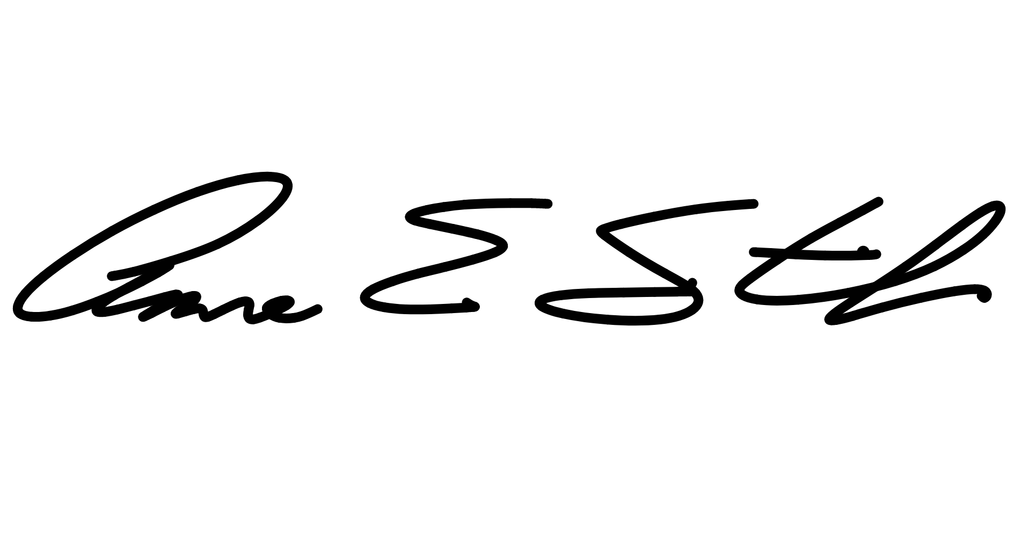
If you have any questions, please feel free to contact me at (785) 537-6346. Sincerely,

Anne Smith
Chairperson - Kansas Coordinated Transit District Council cc: Taylor Zortman, Kansas Department of Transportation

